Table of Contents

**HEADER**  **2**

section menu  3

**FOOTER**  **3**

**PAGE - HOME**  **3**

hero section  3

section - our services  6

News Section  7

testimonials section  9

**PAGE - LIST OF NEWS**  **9**

Hero Section  9

Section map  11

**PAGE – NEWS 1**  **15**

Hero Section  16

**PAGE – NEWS 2**  **16**

Hero Section  17

Section content  17

**PAGE – NEWS 3**  **18**

Hero Section  18

Section content  18

**PAGE – NEWS 4**  **21**

Hero Section  21

**h1 - The contempt has gone on long enough!**  **22**

**Text- 11/09/2024 - 11:41**  **22**

Section content  22

**PAGE – NEWS 5**  **22**

Hero Section  23

**h1 - A radical building plan in England**  **23**

Section content  23

**PAGE – NEWS 6**  **23**

Hero Section  24

**21/08/2024 - 11:54**  **24**

Section content  24

Hero Section  25

**h1 - Demonstrate in Quebec on September 14 and 15,**  **25**

**20/08/2024 - 13:30**  **25**

Section content  25

**PAGE – NEWS 8**  **26**

Hero Section  26

Section content  26

**PAGE – NEWS 9**  **28**

Hero Section  28

Section content  28

**PAGE – NEWS 10**  **30**

Hero Section  30

Section content  30

**PAGE – NEWS 11**  **31**

Hero Section  32

Section content  32

**PAGE – NEWS 12**  **33**

Hero Section  33

Section content  33

**PAGE – NEWS 13**  **34**

Hero Section  34

Section content  34

**PAGE - LIST OF SERVICES OFFERED**  **35**

congress section  35

CCR section  38

tenant section at CA  39

section bulletins  41

newsletters section  42

practical guide section  45

**PAGE - A SERVICE**  **55**

**PAGE - TEAM**  **56**

**PAGE - ABOUT**  **57**

historical section  58

**PAGE - CONTACT US**  **69**

**PAGE - FAQ**  **70**

**PAGE - ERROR 404**  **71**

# HEADER

## Banner Section

This page is merely an academic project aimed at transforming an existing site. Please visit the current site:

## Menu Section

TEAM   
SERVICES   
NEWS   
ABOUT   
FAQ   
CONTACT US

# **FOOTER**

Federation of Low-Income Housing Tenants of Quebec

2520 Lionel-Groulx Ave, Suite 202   
Montreal, Quebec   
H3J 1J8

1-800-566-9662

info@flhlmq.com   
2024, Federation of Low-Income Housing Tenants of Quebec

Join our organization

(Button) BECOME A MEMBER [ <https://flhlmq.us9.list-manage.com/subscribe?u=1af72b6ef5b6dda4c1b7a6655&id=06faa42531>]

# **PAGE - HOME**

( <https://flhlmq.com/en>)

## **Hero Section**

H1 - THE FEDERATION OF LOW-INCOME HOUSING TENANTS OF QUEBEC

(Carousel Page 1)



H3 - Send an Email to Support Alexis! [https://flhlmq.com/en/article/send-an-email-to-support-alexis]

(Carousel Page 2)

H3 - "I Live in a Public Housing Unit, and That's a Chance I Have" [https://flhlmq.com/en/article/i-live-in-a-public-housing-unit-and-thats-a -chance-i-have]

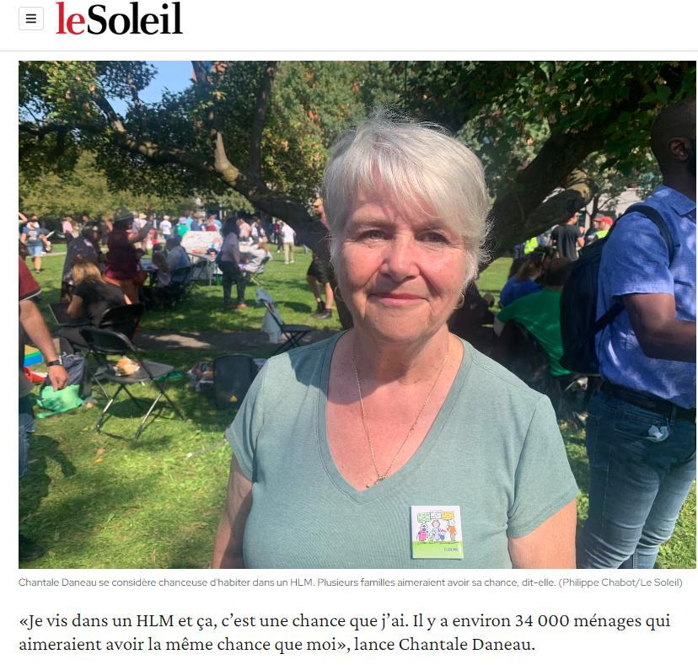

(Carousel Page 3)

**H3** - Petition for Quality Public Housing [https://flhlmq.com/en/article/petition-for-quality-public-housing]



## 

## Become a Member Section

H1 - Why Become a Member of FLHLMQ?

By your membership fee to be a member of FLHLMQ, you allow us to represent tenants from all over Quebec and to stay in contact with you to assist you at all times. In the case of CCRs, you can ask the office to pay your membership fee to FLHLMQ.

H2 - FLHLMQ Membership Form

Together, We Are Stronger! Join the Movement!

H3 – Identification of Your Association

Name of Association:   
1st Contact Person:   
Title (President, Secretary, etc.):   
Address:   
City:   
Postal Code:   
Phone:   
Email:

2nd Contact Person:   
Title (President, Secretary, etc.):   
Address:   
City:   
Postal Code:   
Phone:   
Email:

H3 - Type and Number of Housing Represented by Your Association   
Number of Housing Units for Seniors:   
Number of Housing Units for Families:   
Number of Housing Units for Persons with Disabilities:

H3 - Annual Membership Fee   
☒   
☐ Association and/or CCR* representing 40 units or fewer: $25/year   
☐ Association and/or CCR* representing 41 to 100 units: $50/year   
☐ Association and/or CCR* representing 101 units or more : $75/year

* Membership fees for CCRs can be paid by your office.

2520 Lionel-Groulx Ave, Suite 202, Montreal (Quebec) H3J 1J8   
Phone: 1-800-566-9662   
Fax: (514) 521-6444   
info@flhlmq.com   
www.flhlmq.com

## 

## **Section - Our Services**

H1 - OUR SERVICES

H2 - SERVICE 01 - THE CONGRESS   
To promote and defend the interests of tenants and work towards improving their quality of life.

H2 - SERVICE 02 - THE NEWSLETTER   
Every month, FLHLMQ shares with you the most significant concerns and actions of those who are trying to change life in their public housing units.

H2 - SERVICE 03 - HEALTHY ENVIRONMENT   
To provide support for the work done locally by tenant associations and to encourage tenant involvement and ownership in public housing units.

H2 - SERVICE 04 - ADVISORY COMMITTEE   
To represent tenants before political and administrative bodies.

## Section - News

H1 - NEWS NEWS NEWS

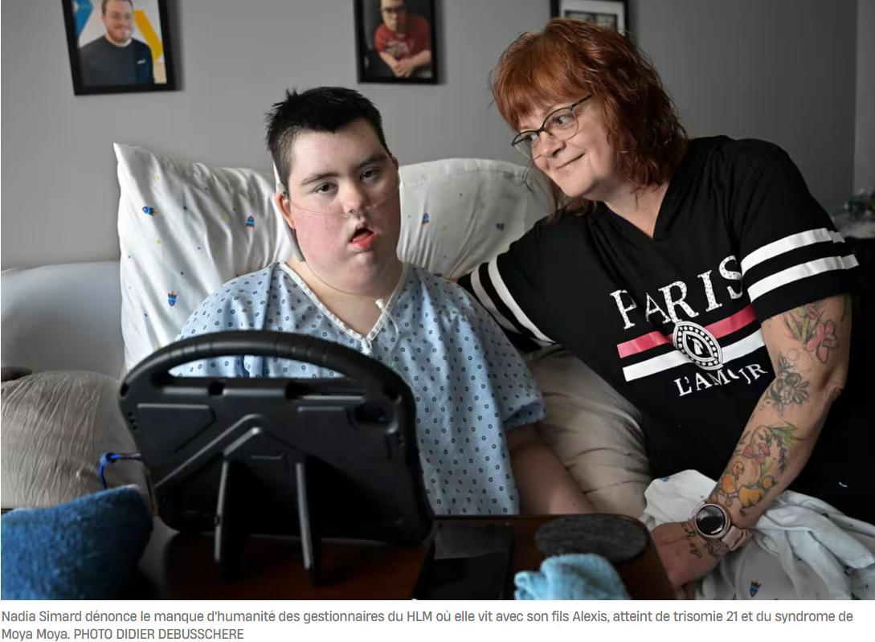

[https://flhlmq.com/en/article/send-an-email-to-support-alexis]

H3 - Send an Email to Support Alexis!

The OMH refuses funding from the SHQ to help a young man with Down syndrome who is at the end of his life.



[https://flhlmq.com/en/article/i-live-in-a-public-housing-unit-and-thats-a-chance-i-have]

H3 - "I Live in a Public Housing Unit, and That's a Chance I Have"

Chantal Daneau's testimony in favor of new public housing units.



[https://flhlmq.com/en/article/petition-for-quality-public-housing]

H3 - Petition for Quality Public Housing - 09/11/2024

FLHLMQ aims to collect 10,000 signatures.

## 

## Section - Testimonials

H1 - TESTIMONIALS

H2 - User 01   
I joined this community of landlords and tenants a few years ago, and since then, I feel right at home! Everyone is friendly and helpful, making community living easier and more enjoyable.

H2 - User 02   
Since I've been here, I've been able to meet new people and feel more connected to others. It's like I've found a welcoming and supportive family.

H2 - User 03   
The tenant community is great! I love the friendly atmosphere.

PAGE - NEWS LIST   
(https://flhlmq.com/en/news)   
Hero Section   
H1 - THE FEDERATION OF LOW-INCOME HOUSING TENANTS OF QUEBEC   
(Carousel Page 1)   
H3 - Send an Email to Support Alexis! [https://flhlmq.com/en/article/send-an-email-to-support-alexis]



(carousel page 2)

H3- [“I live in a council house and that’s a lucky thing for me”](https://flhlmq.com/fr/article/je-vis-dans-un-hlm-et-ca-cest-une-chance-que-jai)

[ <https://flhlmq.com/fr/article/je-vis-dans-un-hlm-et-ca-cest-une-chance-que-jai>]



(carousel page 3)

H3- [Petition for quality social housing](https://flhlmq.com/fr/article/petition-pour-des-hlm-de-qualite)

[ <https://flhlmq.com/fr/article/petition-pour-des-hlm-de-qualite>]



## Map section



H3- [Send an email to support Alexis!](https://flhlmq.com/fr/article/envoyez-un-courriel-pour-soutenir-alexis)

[ <https://flhlmq.com/fr/article/envoyez-un-courriel-pour-soutenir-alexis>]

September 17, 2024

The OMH refuses funds from the SHQ to help a young person with Down syndrome at the end of his life.



H3- [“I live in a council house and that’s a lucky thing for me”](https://flhlmq.com/fr/article/je-vis-dans-un-hlm-et-ca-cest-une-chance-que-jai)

[ <https://flhlmq.com/fr/article/je-vis-dans-un-hlm-et-ca-cest-une-chance-que-jai>]

September 16, 2024

Chantal Daneau’s testimony in favor of new social housing.



H3- [Petition for quality social housing](https://flhlmq.com/fr/article/petition-pour-des-hlm-de-qualite)

[ <https://flhlmq.com/fr/article/petition-pour-des-hlm-de-qualite>]

September 11, 2024

The FLHLMQ hopes to collect 10,000 signatures.

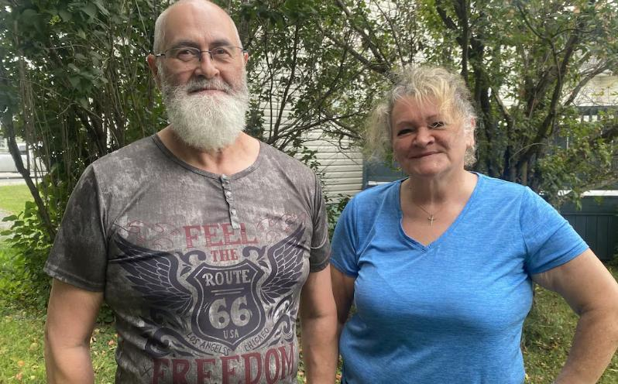

H3- [The contempt has gone on long enough!](https://flhlmq.com/fr/article/le-mepris-assez-dure)

[https://flhlmq.com/fr/article/le-mepris-assez-dure]

September 11, 2024

The Lake Abitibi Housing Office must change its attitude.



H3- [Groundbreaking ceremony for Unitaînés in Rimouski](https://flhlmq.com/fr/article/premiere-pelletee-de-terre-pour-unitaines-rimouski)

Text- September 10, 2024

Offices should not depend on others to fulfill their mission.

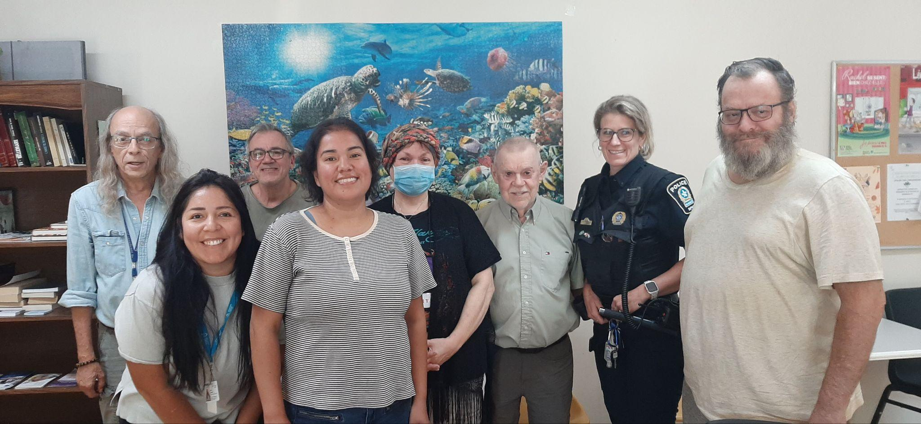

H3- [Community security in a Montreal HLM](https://flhlmq.com/fr/article/securite-communautaire-dans-un-hlm-de-montreal)

Text- September 5, 2024

Tenants are not alone!

# PAGE – NEWS 1

( <https://flhlmq.com/fr/article/envoyez-un-courriel-pour-soutenir-alexis>)

## Hero Section



h1 - Send an email to support Alexis!

[ <https://flhlmq.com/fr/article/envoyez-un-courriel-pour-soutenir-alexis>]

Text- 09/17/2024 - 12:03

Section content

H3- A young disabled Down syndrome patient at the end of his life can no longer even go outside because the municipal housing office that manages his social housing refuses to install a lift, even though exceptional funds have been released for this purpose.

See the article in the Journal de Québec:

[https://www.journaldequebec.com/2024/09/17/lomh-refuse-dadapt-son-logement-un-jeune-trisomique-en-fin-de-vie-coince-chez-lui](https://www.journaldequebec.com/2024/09/17/lomh-refuse-dadapter-son-logement-un-jeune-trisomique-en-fin-de-vie-coince-chez-lui)

If you feel like it, the FLHLMQ invites you to send an email to the mayor of the municipality of Baie-Saint-Paul and to the acting mayor who is also president of the OMH.

You could help us by sending a simple message like:

For humanitarian reasons, I would like you to accept the offer from the Société d'habitation du Québec to grant an exceptional budget of $50,000 for the installation of an elevator outside Ms. Simard's home .

Send your email to the following two addresses:

maire@baiesaintpaul.com

district5@baiesaintpaul.com

The FLHLMQ thanks you for supporting this solidarity action!

# PAGE – NEWS 2

( <https://flhlmq.com/fr/article/je-vis-dans-un-hlm-et-ca-cest-une-chance-que-jai>)

## Hero Section



h1 - "I live in a council house and that's a lucky thing I have"

09/16/2024 - 4:28 p.m.

## Section content

The FLHLMQ was present at the large demonstration bringing together 1,300 people in favor of social housing which took place on September 15 in front of the National Assembly in Quebec.

A member of our board of directors, Chantal Daneau, even made the front page of Le Soleil newspaper and a Radio-Canada report by stating: "I live in a low-cost housing project and that's a lucky thing I have. There are about 34,000 households that would like to have the same luck as me."

During this gathering organized by FRAPRU, 450 people signed the petition FOR QUALITY HLM that all associations and all CCRs will receive by post during the week of September 16.

To read the article in the newspaper Le Soleil:

<https://www.lesoleil.com/actualites/actualites-locales/la-capitale/2024/09/15/la-chance-dhabiter-dans-un-hlm-5L4SZKQNHZADTEKTRYCSCWKI5M/>

# PAGE – NEWS 3

( <https://flhlmq.com/fr/article/premiere-pelletee-de-terre-pour-unitaines-rimouski>)

## Hero Section



h1 - Groundbreaking ceremony for Unitaînés in Rimouski

Text- 10/09/2024 - 09:03

## Section content

Radio Canada highlighted, in a report on September 9, the official groundbreaking ceremony for a 100-unit building built by the Mission Unitaînés, which will then be entrusted to the management of the Rimouski-Neigette Housing Office. The FLHLMQ is delighted with this initiative, which will make a thousand units available to housing offices in a dozen cities over the next 24 months to help the 34,000 households waiting for low-cost housing in Quebec.

At the same time, this initiative from a private foundation makes us realize how scandalous it is that housing offices, which have been the SHQ's main agents for 50 years, must depend on the efforts of others. This is why our federation is urging Minister Duranceau to implement a social housing construction program specific to OHs.

It's day 1 of the construction of 100 new seniors' housing units in Rimouski

[Gabriel Paré-Asatoory (View profile) [https://ici.radio-canada.ca/profil/25601/gabriel-pare-asatoory]](https://ici.radio-canada.ca/profil/25601/gabriel-pare-asatoory)

[Gabriel Pare-Asatoory](https://ici.radio-canada.ca/profil/25601/gabriel-pare-asatoory)

[[https://ici.radio-canada.ca/profil/25601/gabriel-pare-asatoory]](https://ici.radio-canada.ca/profil/25601/gabriel-pare-asatoory)

Listen to the article | 4 minutes

Speech synthesis, based on artificial intelligence, makes it possible to generate spoken text from written text.

The Mission Unitaînés project is coming to fruition: 100 new affordable housing units for low-income seniors are about to see the light of day in Rimouski. A groundbreaking ceremony took place Monday morning.

[The six-storey building will be located on Corneau Street](https://ici.radio-canada.ca/nouvelle/2070495/logements-rimouski-unitaines) [ <https://ici.radio-canada.ca/nouvelle/2070495/logements-rimouski-unitaines>], near the Université du Québec à Rimouski. The first tenants are expected in early 2026.

Mission Unitaînés was created to respond to the [housing] crisis. We work urgently. We work quickly. […] There are 24 months, all inclusive, between obtaining the grant and the delivery of the buildings, explains Caroline Sauriol, president and CEO of the organization.

*It is a quality building that is efficiently built to meet the needs of low-income seniors.*

A quote from Caroline Sauriol, President and CEO of Mission Unitaînés

Once built, the building, which will be operated by the Office d'habitation Rimouski-Neigette (OHRN), will include 15 studios, 74 three-and-a-half and 11 four-and-a-half apartments. Some apartments will cost $600 per month, including electricity, heating and internet.

Mission Unitaînés is also committed to donating $500,000 to the OHRN for its contingency fund. A donation that will allow the project to be financially independent for the next 35 to 50 years, according to the organization's president and CEO.

For the mayor of Rimouski, the start of construction of these housing units constitutes a step in the right direction.

This is not enough, obviously, to completely address the housing shortage, but it is really a good start to help us free up apartments, admits Guy Caron.

The elected official estimates that around 500 housing units will be started in 2024 in Rimouski and as many next year. [That's 200 fewer](https://ici.radio-canada.ca/nouvelle/2076163/logement-rimouski-construction-appartements-combien) [ <https://ici.radio-canada.ca/nouvelle/2076163/logement-rimouski-construction-appartements-combien>] than he anticipated in June.

[150 more apartments](https://ici.radio-canada.ca/nouvelle/2093315/logement-etudiant-utile-bonneville-rimouski) [ <https://ici.radio-canada.ca/nouvelle/2093315/logement-etudiant-utile-bonneville-rimouski>] could however be added by the end of the year, the mayor reminds us. The financial plan for the project of the Work Unit for the Implementation of Student Housing (UTILE) is still not complete.

If the Quebec government can announce an investment, other units could be started this year, he assures.

A concept repeated elsewhere in Quebec

Nine other projects, identical to the one in Rimouski, are planned across the province.

That's our concept. It's the simultaneous construction of identical buildings from one city to another. Sometimes, the exterior cladding, the color of the exterior cladding can vary, but otherwise, the entire interior is identical in the ten buildings that are built at the same time, explains Caroline Sauriol.

In total, 1,000 homes will be built by 2026.

*With information from Isabelle Damphousse*

# PAGE – NEWS 4

( <https://flhlmq.com/fr/article/le-mepris-assez-dure>)

## Hero Section

# 

# h1 - The contempt has gone on long enough!

# Text- 11/09/2024 - 11:41

## Section content

H3- Radio Canada has just published an article on the scandalous situation experienced at the Lac Abitibi housing office: laxity in the rental of housing, contempt for tenants who ask questions, threats against CCR members, etc.

The FLHLMQ is wholeheartedly with the tenants who are right to complain and we hope for a strong intervention from the SHQ to restore transparency and respect for the rules of participation in this office. Above all, and this is not mentioned in the report, all the tenants who are members of the CCR received a formal notice from the OH in order to intimidate them. Unheard of!

H2- How was it discovered that social housing was empty in Abitibi-Ouest?

Social housing tenants acted as whistleblowers in this case. Journalist Jean-Marc Belzile explains how he managed to confirm their information.

[ [*https://ici.radio-canada.ca/info/videos/1-10172505/comment-a-t-on-decouvert-que-logements-sociaux-etait-vides-en-abitibi-ouest*](https://ici.radio-canada.ca/info/videos/1-10172505/comment-a-t-on-decouvert-que-logements-sociaux-etaient-vides-en-abitibi-ouest) *]*

The FLHLMQ will take advantage of the demonstration and camp organized by the FRAPRU to demand social housing, on September 14 and 15, to publicly launch its petition for quality HLM. Starting the following week, all our associations and the CCRs of Quebec will be invited to go door-to-door to collect at least 10,000 signatures and ask their MNA to submit them on their behalf to the National Assembly.

# PAGE – NEWS 5

( <https://flhlmq.com/fr/article/un-plan-radical-de-construction-en-angleterre>)

## Hero Section

# 

# h1 - A radical building plan in England

21/08/2024 - 11:54

## Section content

In England, the new Labour government has announced a plan it wants to be "radical" to combat the housing shortage affecting the country.

Deputy Prime Minister for Housing Angela Rayner has promised “the biggest acceleration in social and affordable housing in a generation”. She has pledged to deliver 1.5 million new homes by the next 5 years. coming years, including by setting mandatory targets for cities.

More than 1.2 million families are waiting to get social housing and homelessness reached a record high in London last year.

If we made a comparison with Quebec, all things considered, this would mean a commitment to build 39,500 new housing units per year. The CAQ promised less than 12,000 for the total duration of its four-year mandate, or barely 3,000 per year, ten times less than Angela Rayner.

# PAGE – NEWS 6

( <https://flhlmq.com/fr/article/une-strategie-qui-limite-4-le-nombre-de-logements-sociaux-venir>)

## Hero Section



h1 - A strategy that limits the number of future social housing units to 4%

# 21/08/2024 - 11:54

## Section content

In England, the new Labour government has announced a plan it wants to be "radical" to combat the housing shortage affecting the country.

Deputy Prime Minister for Housing Angela Rayner has promised “the biggest acceleration in social and affordable housing in a generation”. She has committed to delivering 1.5 million new homes over the next five years, including setting mandatory targets for cities.

More than 1.2 million families are waiting to get social housing and homelessness reached a record high in London last year.

If we made a comparison with Quebec, all things considered, this would mean a commitment to build 39,500 new housing units per year. The CAQ promised less than 12,000 for the total duration of its four-year mandate, or barely 3,000 per year, ten times less than Angela Rayner.

PAGE – NEWS 7 ( <https://flhlmq.com/fr/article/manifestons-quebec-les-14-et-15-septembre>)

## Hero Section



# h1 - Demonstrate in Quebec on September 14 and 15

# 20/08/2024 - 13:30

## Section content

On September 14 and 15, FRAPRU will hold a Camp in Quebec City and a large demonstration to demand social housing. The FLHLMQ will be there and invites you to participate in large numbers in the demonstration on September 15 in Quebec City. Because unity is strength, let's be many to carry a sign "I want HLM".

As the housing crisis continues to worsen and tenant testimonies multiply, the government is slow to announce a major project for new social housing. We know that more than 34,000 households are waiting on the lists of the provincial housing offices and that is why we are demanding a program for a new generation of social housing.

The FLHLMQ invites you to participate in the big event on Sunday, September 15. Departures are organized from Montreal, Lanaudière, the South Shore and the Lower St. Lawrence. Call us for more details at 1-800-566-9662 or 514-521-1485. You can also write to us at info@flhlmq.com

If you are hesitant to participate, click on the image to listen to the testimony of Chantal Daneau, one of the representatives on the FLHLMQ board of directors.

# 

# PAGE – NEWS 8

( <https://flhlmq.com/fr/article/rencontre-avec-benoit-dorais>)

## Hero Section

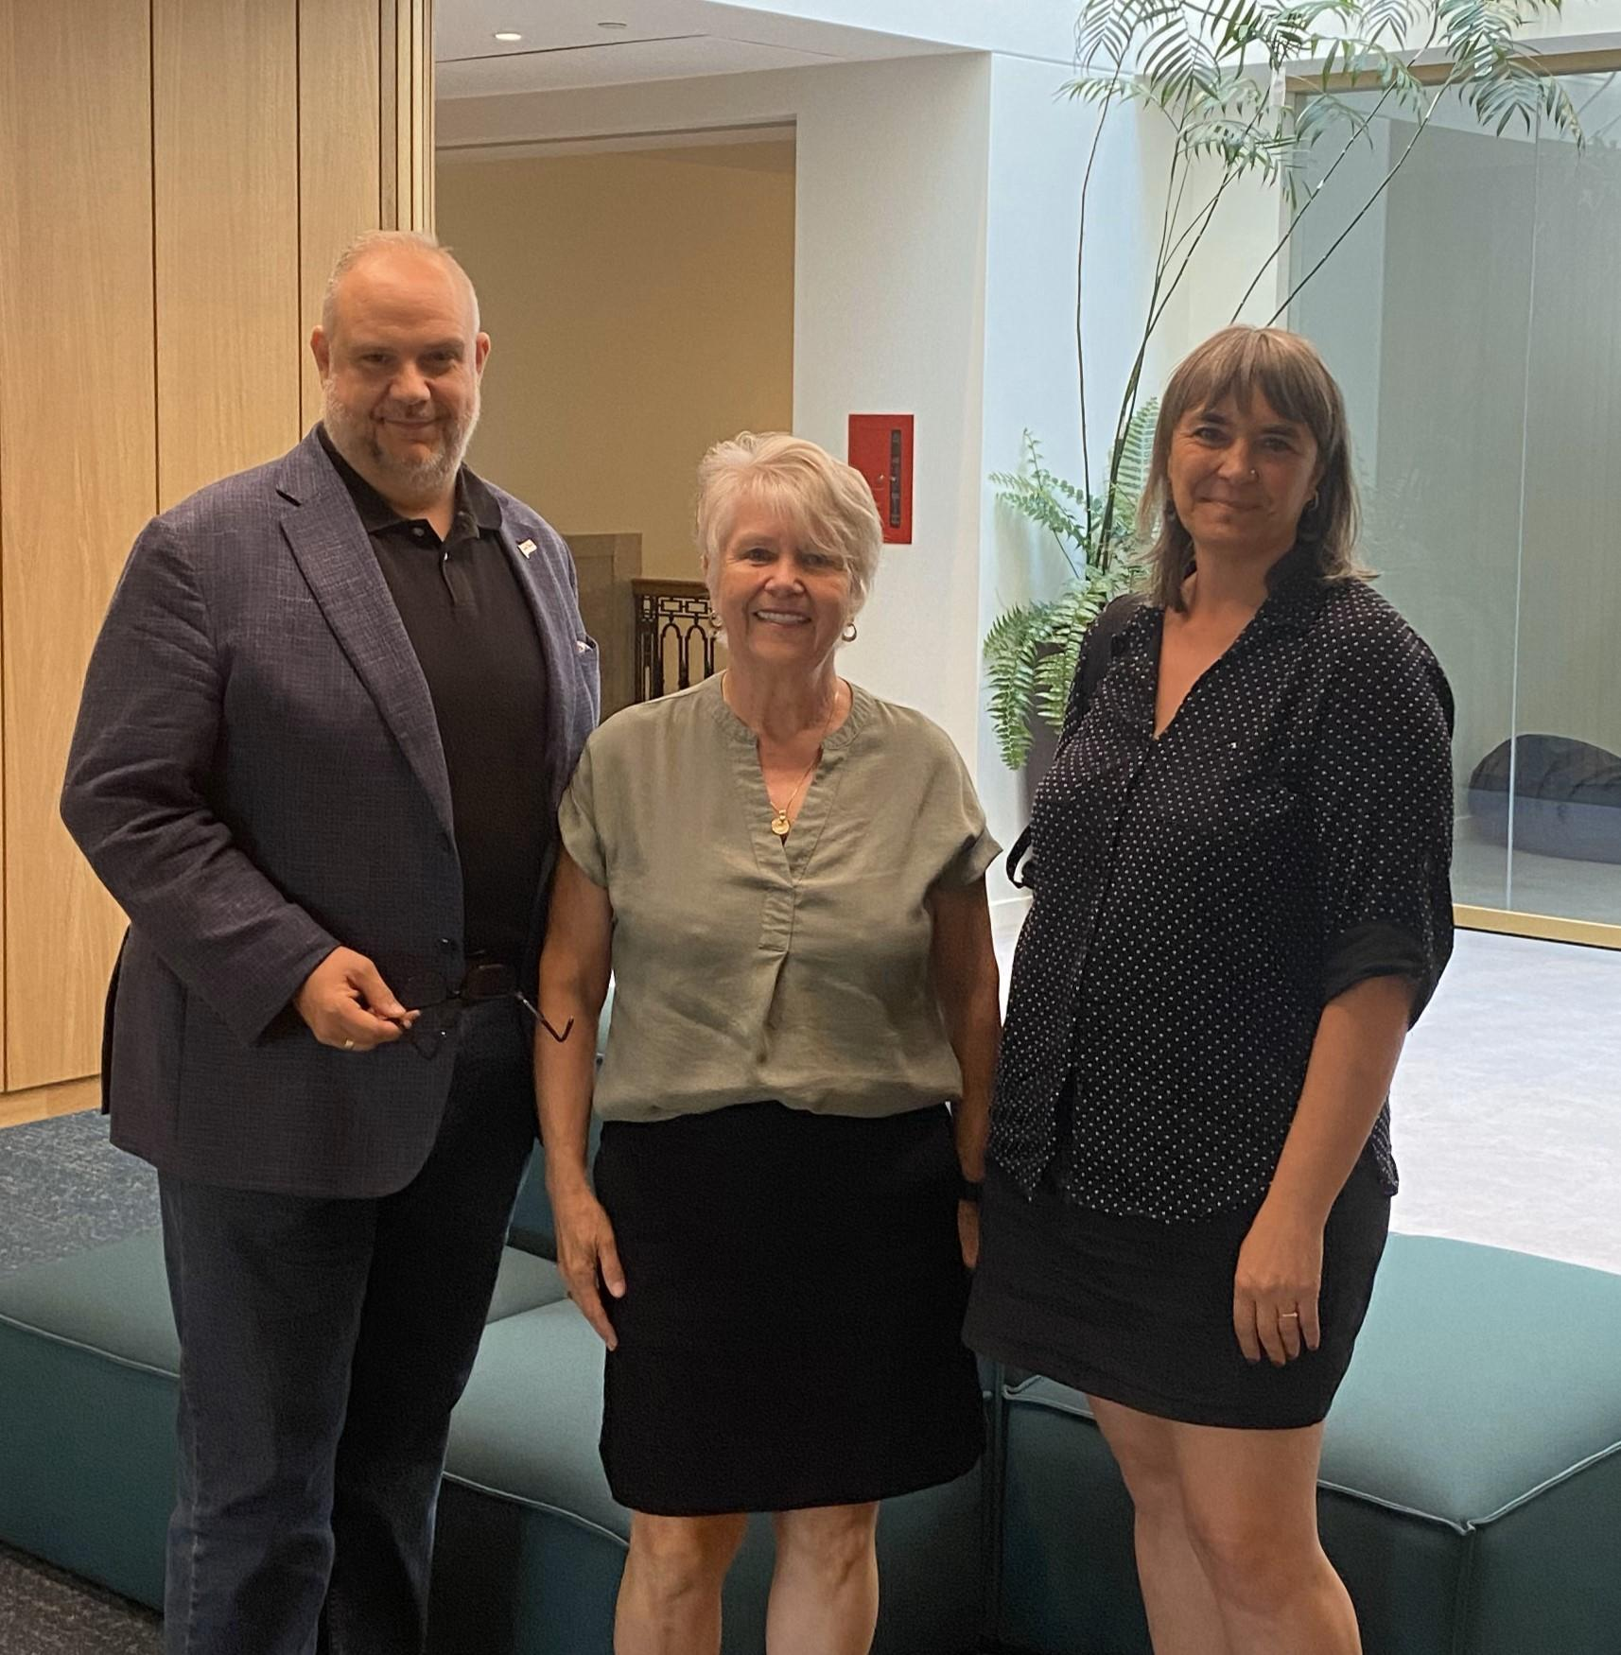

h1 - Meeting with Benoit Dorais

08/19/2024 - 11:17

## Section content

The federation met with the head of housing for the City of Montreal, Mr. Benoit Dorais, who is also the mayor of the Sud-Ouest borough, where we find the largest HLM park in Quebec. Let us recall that the OMHM manages more than 20,000 HLMs, or 1/3 of the HLMs in Quebec. Even if the OMHM is autonomous and managed by an independent board of directors, the City exercises a certain influence through its presence on the board of directors and the financing of a portion of the operating deficit, like all cities.

We were therefore happy to have a listening ear and had a long discussion about the need for major renovations. Like us, the city is pleased that the office finally has $250 million this year to do major work. However, we insisted on the importance of not abandoning those who are currently in their homes and waiting for basic maintenance work. The city confirms that, if necessary, its inspectors can go into the HLMs and work with the OMHM.

We also highlighted the fact that the call centre does not work well for tenants, whether in terms of the quality of service or the response time. Unfortunately, recent events have proven us right again with Montreal tenants without electricity and no response from the OMHM (read the article [Major water leak: HLM plunged into darkness for nearly 30 hours | Radio-Canada](https://ici.radio-canada.ca/nouvelle/2097596/hlm-interruption-panne-electricite-bris-aqueduc?) ) [ <https://ici.radio-canada.ca/nouvelle/2097596/hlm-interruption-panne-electricite-bris-aqueduc>? ]

We also noted that the city wants to rely on the OMHM to respond to the housing crisis and offer new social housing. Benoit Dorais said he is "closely monitoring the work of the development team." Like the federation, the city expects the OMHM to densify its housing stock, when possible. We therefore asked it to support our request for a program dedicated to offices that will allow us to develop a new generation of social housing.

Photo: Benoit Dorais, Chantal Daneau and Patricia Viannay.

# 

# PAGE – NEWS 9

## Hero Section



h1 - The challenges of the new CEO of the SHQ

( <https://flhlmq.com/fr/article/les-defis-du-nouveau-pdg-de-la-shq>)

Text-08/16/2024 - 10:01

## Section content

The Council of Ministers has proceeded with the appointment of the new President and CEO of the Société d'habitation du Québec (SHQ). Mr. Jean Martel will become CEO of the SHQ as of September 23.

Here is how the SHQ presents the arrival of its new CEO:

An engineer by training, Mr. Martel has a thorough knowledge of the challenges related to the construction sector and a mastery of the issues encountered in the housing sector. His excellent understanding of the social issues associated with the needs for social and affordable housing, as well as his ability to manage teams and identify innovative solutions to maximize the effectiveness and efficiency of an organization, will allow him to support the SHQ in fulfilling its mission.

He has led several large-scale engineering, construction and architectural projects for several private companies, including COGIR Immobilier and SNC-Lavalin.

Quotes

“I am delighted that Mr. Martel has taken over as head of the SHQ. Since I took office, the organization has made many changes to the way it tackles housing challenges. We have implemented relevant tools that give stakeholders more flexibility and variety to act on the housing shortage. The time has come to make good use of the toolbox that we can now collectively count on.”   
  
*France-Élaine Duranceau, Minister responsible for Housing*

The challenges of the new CEO

The SHQ has had great difficulty in recent years in renovating the HLM stock and building new, truly social and affordable housing, even though the current CEO was committed to the cause of public housing.

Our federation fervently hopes that the arrival of a new CEO from the largest developers in the private market will, as Minister Duranceau says, help to remove the obstacles to the renovation and mass construction of social housing, particularly through the implementation of a new HLM program for offices.

We will be wholeheartedly with him in achieving this mission if this is indeed the case.

# PAGE – NEWS 10

( <https://flhlmq.com/fr/article/nouveaux-horizons-pour-les-aines>)

## Hero Section

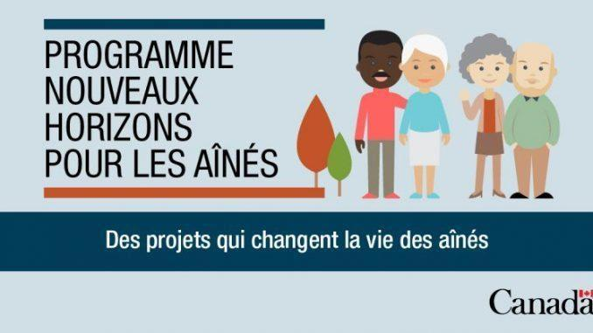

h1 - New Horizons for Seniors

Text-08/16/2024 - 09:28

## Section content

The federal government has just launched its grant program to fund projects for seniors. Tenant associations can obtain up to $25,000 to finance their activities. Applications must be submitted before September 12.

Examples of eligible activities include:

Activities

Applications must demonstrate [active participation](https://www.canada.ca/fr/emploi-developpement-social/services/financement/nouveaux-horizons-aines-communautaires/apercu.html#participation-active) of seniors in eligible activities.

* seniors who share their knowledge, skills and experience with other seniors;
* seniors who raise awareness about elder abuse, including financial exploitation;
* Seniors reaching out to vulnerable seniors, such as those who are socially or geographically isolated, including newcomers, Indigenous seniors or members of the 2SLGBTQIA+ community;
* volunteering, mentoring, leadership training and skills matching for activities with seniors;
* seniors who participate in the development and sharing of tools and resources for the benefit of other seniors;
* the purchase or replacement of equipment for programs and activities for seniors;
* renovation and repair of facilities for programs and activities for seniors;
* transportation to provide personal service to seniors in urban, rural and remote areas (transportation services for appointments, home visits or service calls, meal delivery service, etc.);
* transportation service to enable seniors to travel to the place of the main activity for those on low incomes who would not be able to reach it otherwise, if the main activities are eligible;
* establish partnerships to encourage new cohorts of seniors to participate more actively in community activities;
* adapt approaches (policies and tools) to more effectively attract, recruit and retain diverse cohorts of older volunteer workers;
* seniors who engage in intergenerational learning and relationship building to develop their community networks.

Each year, several associations in Quebec's social housing communities succeed in obtaining a grant under the New Horizons program.

To obtain the application form:

[https://www.canada.ca/fr/emploi-developpement-social/services/financing/nouveaux-horizons-aines-communautaires.html](https://www.canada.ca/fr/emploi-developpement-social/services/financement/nouveaux-horizons-aines-communautaires.html)

# PAGE – NEWS 11

( <https://flhlmq.com/fr/article/salaires-peu-competitifs-dans-les-offices>)

## Hero Section

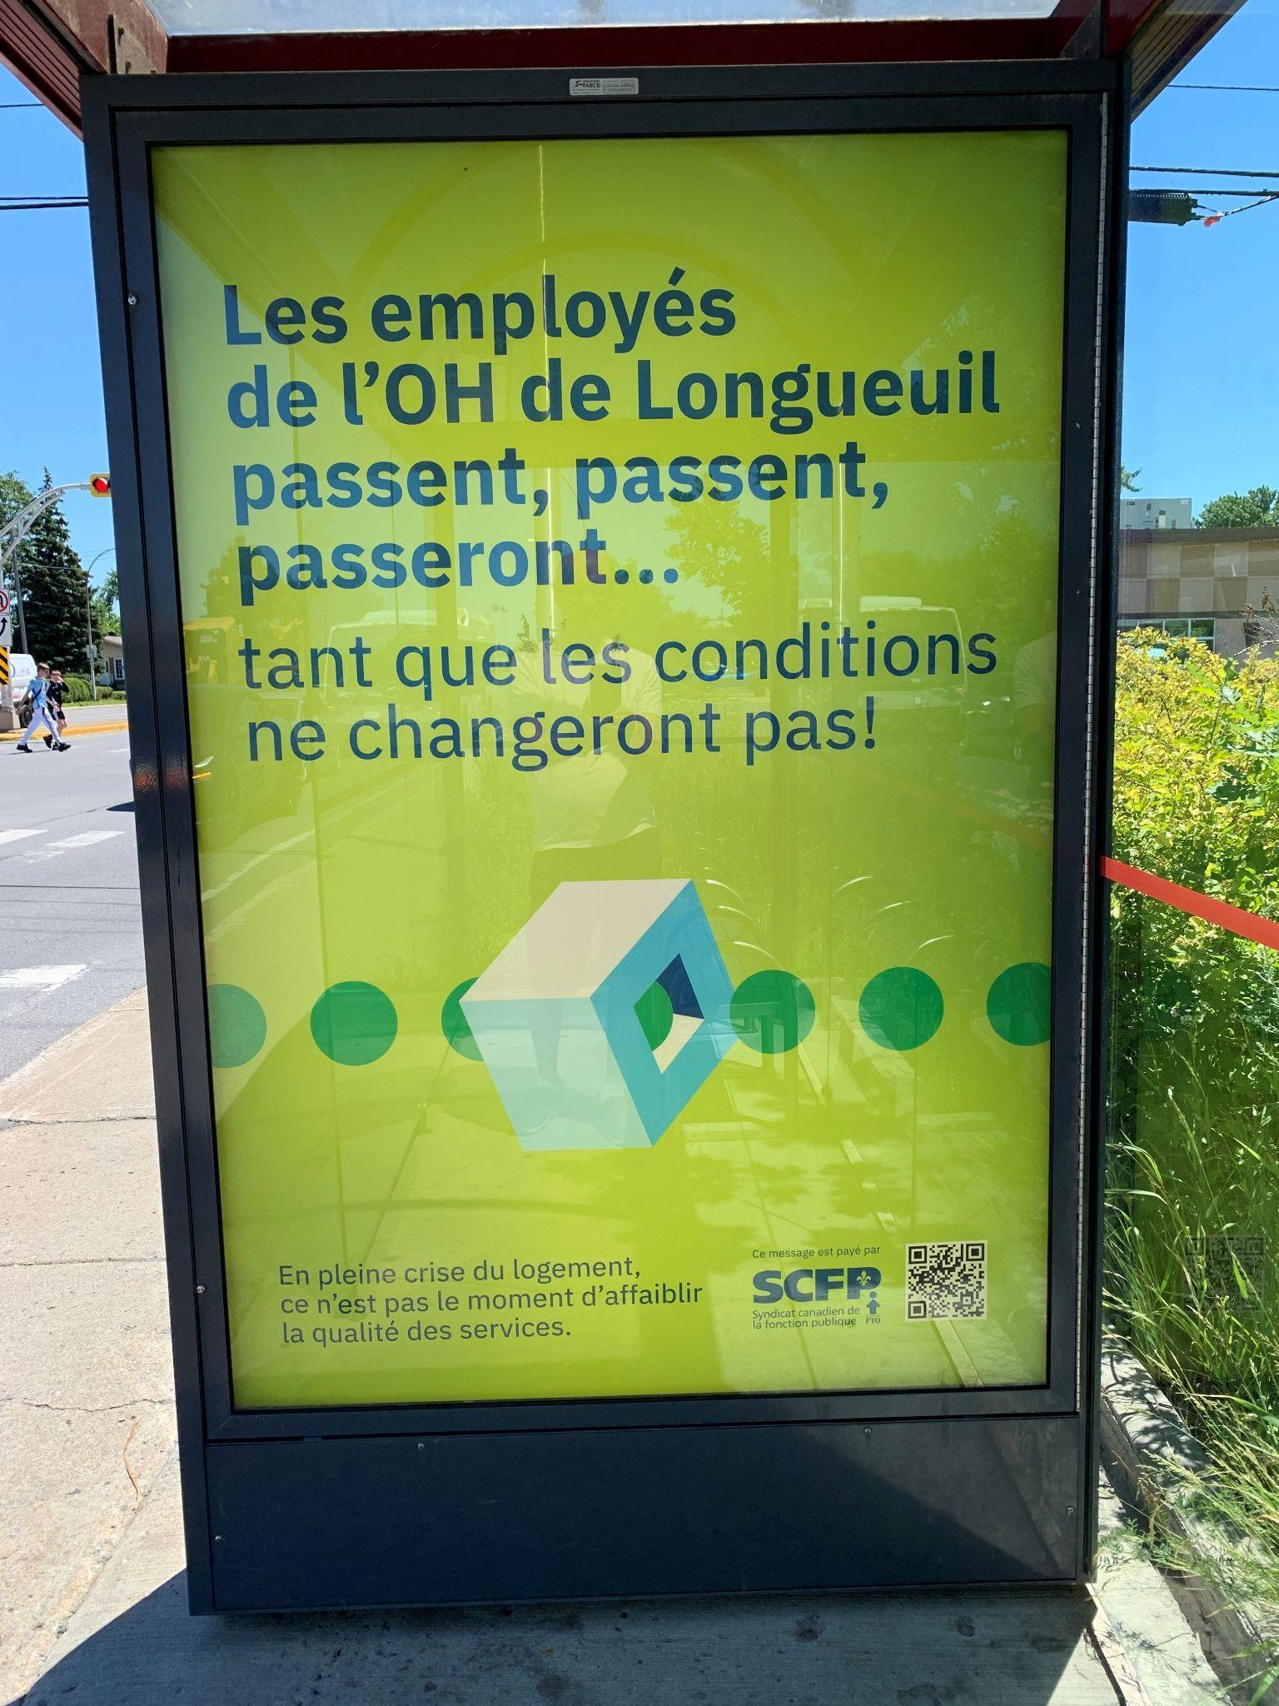

h1 - Uncompetitive salaries in offices

*1* 2/08/2024 - 11:39

## Section content

In Longueuil, the office employees have launched an advertising campaign to denounce their poor pay conditions. The local CUPE union says that salaries are too low due to inflation in recent years and that staff are leaving at full capacity. This high staff turnover rate means that 21 of their 33 members have less than two years of seniority and that this lack of experience affects the quality of services offered to tenants in terms of maintenance, rental and community support.

In January 2024, the FLHLMQ denounced the fact that the offices' room for maneuver to ensure the proper maintenance of our HLMs had been reduced by 7.8% over the last two years due to the failure to index their budget to the real cost of inflation. We warned of a future decline in the quality of services.

At our June congress, associations formulated a proposal asking that the federation mobilize on this issue which is becoming a concern in many offices which are struggling to keep their employees.

Offices and tenants will have every interest in joining forces on this issue this fall if we want to obtain an increase in office budgets for the year 2025.

# 

# PAGE – NEWS 12

( <https://flhlmq.com/fr/article/un-nouveau-dg-au-rohq>)

## Hero Section

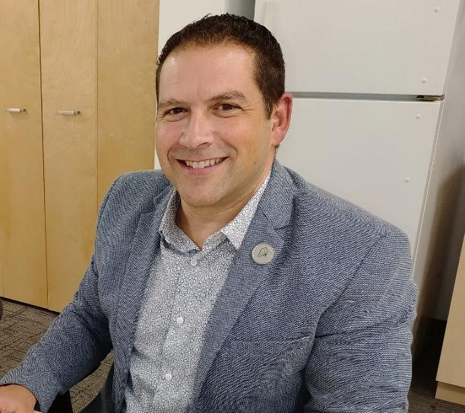

h1 - A new DG at ROHQ

12/08/2024 - 09:45

## Section content

In July, the FLHLMQ received some good news! The Regroupement des offices d'habitation du Québec (ROHQ) announced the identity of the person who will be their new general manager as of August 26: Antonio Ciarciaglino, who was previously the director of the Lanaudière Sud Housing Office.

Our federation is pleased with this choice because we had the opportunity to appreciate his work within the Lanaudière Sud office but also his involvement as president of the Association of Housing Office Directors during the meetings of the Round Table on Public HLM. We are confident that this appointment will allow us to expand our collaborations with our office partners in order to ensure the renovation and development of the HLM park as well as better services for those who live there.

# 

# PAGE – NEWS 13

( <https://flhlmq.com/fr/article/hlm-en-tres-mauvais-etat-baie-saint-paul>)

## Hero Section

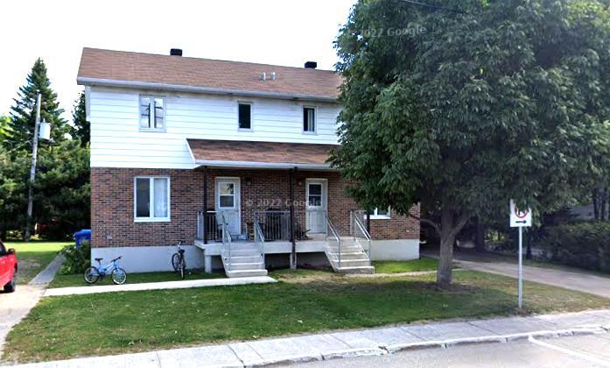

h1 - HLM in very poor condition in Baie-Saint-Paul

## Section content

*Since last February, the FLHLMQ has been deploring the situation in Baie-Saint-Paul, where the city council decided to stop a project to renovate six HLM housing units because of the cost of the work, and has since minimized the seriousness of the situation experienced by the tenants of its buildings. In May, the FLHLMQ also criticized the project of a false merger that will not allow the office to improve its capacity to properly manage its 56 HLM housing units. Fortunately, the media pressure of the last few weeks has forced the OH to take certain actions for the benefit of the tenants suffering from the situation. For the rest, we are waiting to see the position that the SHQ will take on both the HLM renovation project and the profoundly ridiculous merger project that does not involve any other office in the region!*

Dilapidated social housing in Baie-Saint-Paul: 2 tenants relocated

CIHO news - Charlevoix - Written by [Kevin Vallée](https://cihofm.com/equipe/#kevin-vall%C3%A9e) Date: August 7.

One of the tenants who had anonymously testified about the dilapidated state of her home in a report by FM Charlevoix was finally relocated last weekend. "According to my information, she says she is very satisfied with her new home," says Gaston Duchesne, chairman of the board of directors of the Baie-Saint-Paul Municipal Housing Office.

Questioned following [these testimonies](https://cihofm.com/news/hlm-insalubres-et-non-adaptes-des-residents-de-baie-saint-paul-temoignent/) , [Mr. Duchesne indicated that he had visited the accommodation in question and had not found it to be in a “serious” condition](https://cihofm.com/news/hlm-insalubres-et-non-adaptes-gaston-duchesne-defend-lomh/) [https://cihofm.com/news/hlm-insalubres-et-non-adaptes-des-residents-de-baie-saint-paul-temoignez/].

After the tenant moves out, the accommodation in question will remain vacant.

Gaston Duchesne indicates that the decision was made in part because of the dilapidated appearance of the housing, specifying that the OMH is also waiting for a response from the Société de l'Habitation du Québec [for a project to renovate six housing units on rue Forget](https://cihofm.com/news/baie-saint-paul-demande-a-lomh-de-revoir-un-projet-de-refection-de-logements-de-2-millions-de-dollars/) [ <https://cihofm.com/news/baie-saint-paul-demande-a-lomh-de-revoir-un-projet-de-refection-de-logements-de-2-millions-de-dollars/>]. Although no timeline has been set and the scenario is expected to be completed by 2025-2026, it is to limit future relocations that the housing will not be re-rented, says Mr. Duchesne.

The Société d'Habitation du Québec indicated by email that another tenant on rue Forget had been relocated for the same reasons in June, information that the OMH subsequently confirmed.

"The Baie-Saint-Paul OMH and the service centre that serves it have submitted a special project that is being analyzed by the SHQ. Once authorization is granted, a plan will be established for the relocation of the other tenants," we can read in an email response from the Company.

# 

# PAGE - LIST OF SERVICES OFFERED

## congress section

*h1-* democratic life

The FLHLMQ brings together on a voluntary basis some 300 tenant associations and CCRs that are free and independent. Much effort is made to ensure a strong and democratic associative life. In addition to the meetings of the federation's board of directors, which bring together representatives from all regions of Quebec, there are regular regional meetings that allow exchanges between tenants and/or members of the association boards of directors.

*h3* - The Congress

The congress, which is generally held every June, is a crucial moment in the life of the association. More than 200 delegates meet there to discuss, vote on the main orientations of the federation and elect the board of directors. Each association and CCR can present proposals which are discussed and voted on by the delegates. It is on the basis of the proposals that have been adopted that the work of the federation, in particular that of the CA and the work team, will be structured for the next year.

Each congress also allows for exchanges between delegates and certain key government ministers - municipal affairs, employment and solidarity, seniors' secretariat - or representatives of the SHQ.

The regional caucuses take advantage of the congress to choose their representative on the FLHLMQ board of directors.

association section

*h1-* Your tenants association

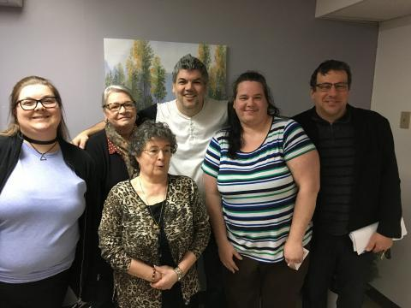

A tenants' association is a group of tenants of one or more social housing projects. This association is set up by tenants and for tenants. The association is managed like an NPO and must have its own board of directors, sometimes called a committee. The association ensures the well-being and improvement of the quality of life of tenants. It is an autonomous organization that decides on its method of organization and the activities it wants to carry out.

There are nearly 400 HLM tenant associations across Quebec. Most of these associations are members of the FLHLMQ. [The Société d'habitation du Québec](https://flhlmq.com/files/Loi%20de%20la%20SHQ.pdf) (SHQ) Act requires all HLMs to recognize any association bringing together tenants of its buildings on the condition that it respects certain founding and operating rules that can be found in [the Directive on tenant participation](http://www.habitation.gouv.qc.ca/fileadmin/internet/documents/partenaires/guides/Manuel_Gestion_ChapB_sec3.pdf) .

*h3* - Role of the FLHLMQ

The SHQ recognizes the right of the FLHLMQ to hold meetings for tenants in order to allow the establishment of tenant associations or to ensure their democratic functioning. Upon written request from the FLHLMQ, the OMH must allow such meetings to be held.

The FLHLMQ has published two guides to help tenants found an association. They can be downloaded.

* [Having an association: a plus for social housing tenants](https://flhlmq.com/sites/flhlmq.com/files/Guide%20pour%20cr%C3%A9er%20une%20association%20de%20locataires%2022%20juillet%202019_0.pdf) , PDF version, 8 pages [ <https://flhlmq.com/sites/flhlmq.com/files/Guide%20pour%20cr%C3%A9er%20une%20association%20de%20locataires%2022%20juillet%202019_0.pdf>]
* [Together to act](http://flhlmq.com/sites/flhlmq.com/files/images-dans-les-textes/Ensemble_pour_agir_Sept.VF_.pdf) , 2015 edition, PDF version, 103 p. [ <http://flhlmq.com/sites/flhlmq.com/files/images-dans-les-textes/Ensemble_pour_agir_Sept.VF_.pdf>]

*h3* - Training video on the establishment and proper functioning of a tenants' association

[Watch the first block](https://youtu.be/YnW6u_VQpeI) and the [powerpoint presentation](http://flhlmq.com/sites/flhlmq.com/files/images-dans-les-textes/bloc%201%20final.pdf)

[ <https://youtu.be/YnW6u_VQpeI>]

[ <http://flhlmq.com/sites/flhlmq.com/files/images-dans-les-textes/bloc%201%20final.pdf>]

[Watch the second block](https://youtu.be/DG7zL9QhCNY) and the [powerpoint presentation](http://flhlmq.com/sites/flhlmq.com/files/images-dans-les-textes/bloc%202%20final.pdf)

[ <https://youtu.be/DG7zL9QhCNY>]

[ <http://flhlmq.com/sites/flhlmq.com/files/images-dans-les-textes/bloc%202%20final.pdf>]

[Watch the third block](https://youtu.be/vlYTIJaJuzs) and the [powerpoint presentation](http://flhlmq.com/sites/flhlmq.com/files/images-dans-les-textes/bloc%203.%20final_0.pdf)

[ <https://youtu.be/vlYTIJaJuzs>]

[ <http://flhlmq.com/sites/flhlmq.com/files/images-dans-les-textes/bloc%203.%20final_0.pdf>]

*h3* - Category

[Tenant participation](https://flhlmq.com/fr/categories/participation-des-locataires)

* [Role of an association](https://flhlmq.com/fr/role-dune-association)
* [Foundation of an association](https://flhlmq.com/fr/fondation-dune-association)
* [How an association works](https://flhlmq.com/fr/fonctionnement-dune-association)
* [Finances](https://flhlmq.com/fr/finances)
* [Activities](https://flhlmq.com/fr/activites)

[Role of an association](https://flhlmq.com/fr/role-dune-association)

SUMMARY

* [Role of an association](https://flhlmq.com/fr/role-dune-association)
* [Foundation of an association](https://flhlmq.com/fr/fondation-dune-association)
* [How an association works](https://flhlmq.com/fr/fonctionnement-dune-association)
* [Finances](https://flhlmq.com/fr/finances)
* [Activities](https://flhlmq.com/fr/activites)

## CCR section

*h1-* Get involved in the CCR

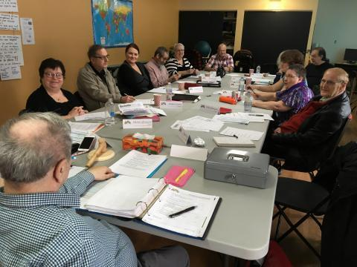

A Residents' Advisory Committee is a body that allows HLM tenants to participate in the management of their building and to make recommendations to the OMH management on all issues that affect them. A CCR is composed solely of tenants designated by the associations. All offices are required to have one and must support it.

*h3* - A [CCR](http://flhlmq.site.koumbit.net/glossary/term/91) is a plus!

The participation of tenants in the management and community life of the offices is a PLUS that has not diminished over the years. On the contrary, the experience acquired in many offices shows its richness. This participation is a fundamental element in meeting the challenges that arise in social housing, today and in the future. Whether it is for maintaining the quality of housing, the harmony of the living environment or the resources to be developed to promote remaining at home or social reintegration, the collaboration of tenants is essential.

Since April 2002, the [SHQ Act](https://flhlmq.com/files/Loi%20de%20la%20SHQ.pdf) has required each of Quebec's housing offices to set up a CCR. Beyond the law, experience shows that the CCR is a valuable tool in managing an office. More than half of the housing offices have set one up.

In the case of large offices, the Act also provides for the establishment of sector committees to discuss more specifically direct services to residents and their complaints.

The SHQ has mandated the FLHLMQ to provide the necessary support for setting up CCRs. Do not hesitate to call on its services to found or support your CCR.

*h3* -To learn more about how the CCR works:

* [How to set up your Residents’ Advisory Committee (RAC)?,](https://flhlmq.com/sites/flhlmq.com/files/images-dans-les-textes/Guide%20CCR%202016.pdf) 2016 edition, pdf version, 8 p.

[ <https://flhlmq.com/sites/flhlmq.com/files/images-dans-les-textes/Guide%20CCR%202016.pdf>]

* [Resident Advisory Committees](https://flhlmq.com/sites/flhlmq.com/files/images-dans-les-textes/Guide%20CCR%20-%20%C3%A9dition%20novembre%202018.pdf) , PDF version, 64 pages

[ [https://flhlmq.com/sites/flhlmq.com/files/images-dans-les-textes/Guide%20CCR%20-%20%C3%A9dition%20november%202018.pdf](https://flhlmq.com/sites/flhlmq.com/files/images-dans-les-textes/Guide%20CCR%20-%20%C3%A9dition%20novembre%202018.pdf) ]

*h3* - Category

[Tenant participation](https://flhlmq.com/fr/categories/participation-des-locataires)

* [Role of a CCR](https://flhlmq.com/fr/role-dun-ccr)
* [Foundation of a CCR](https://flhlmq.com/fr/fondation-dun-ccr)
* [How a CCR works](https://flhlmq.com/fr/fonctionnement-dun-ccr)
* [Finances](https://flhlmq.com/fr/finances-0) [
* [CCRs elsewhere…](https://flhlmq.com/fr/des-ccr-ailleurs)

[Role of a CCR](https://flhlmq.com/fr/role-dun-ccr)

SUMMARY

* [Role of a CCR](https://flhlmq.com/fr/role-dun-ccr)
* [Foundation of a CCR](https://flhlmq.com/fr/fondation-dun-ccr)
* [How a CCR works](https://flhlmq.com/fr/fonctionnement-dun-ccr)
* [Finances](https://flhlmq.com/fr/finances-0) [
* [CCRs elsewhere…](https://flhlmq.com/fr/des-ccr-ailleurs)

## tenant section at the CA

*h1-* Be on the OMH Board of Directors

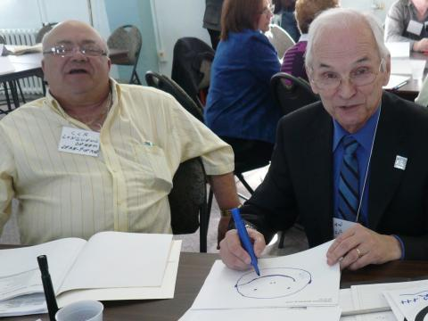

The SHQ Act provides that the board of directors (CA) of a housing office is composed of a fixed number of directors, which can be from five to fifteen people. It is made up of people designated by the municipalities, two people appointed by the Minister of Municipal Affairs who are the socio-economic representatives and two or three tenant representatives elected by the members of the residents' advisory committee from among all tenants having a lease with the office.

*h3* - The role of the director

The director is not a member of the board of directors. As the office's principal employee, he or she attends board meetings to provide information and report on its management. He or she has observer status on the board.

*h3* - Administrators are equal in law

All administrators are equal in law. This means that whether you are tenants, municipal elected officials or socio-economic representatives, you also have the right:

* To be elected to the presidency, vice-presidency, secretariat or treasurer of the board of directors. Nothing prevents a tenant from being elected to the position of president of the office or to a position of officer on the CA;
* To require that the director report on his or her administration to the CA on a regular basis;
* To formulate proposals which, if supported, will have to be discussed and put to a vote;
* To obtain all the information necessary to make informed decisions, including having access to all documents;
* In the event of serious disagreement, to have one's dissent recorded in the minutes;
* In the event of non-compliance with the code of ethics, complain to the president of the board of directors of the office and to the president and CEO of the SHQ, who is responsible for enforcing the code.   
  The FLHLMQ has produced a guide for tenants on the board of directors of offices. You can download it.
* [Enter the administrator code](https://flhlmq.com/sites/flhlmq.com/files/guidePourAgirCA_guide_vert_12.pdf) , PDF version, 44 pages

[ <https://flhlmq.com/sites/flhlmq.com/files/guidePourAgirCA_guide_vert_12.pdf>]

*h3* - Category

[Tenant participation](https://flhlmq.com/fr/categories/participation-des-locataires)

* [Elections](https://flhlmq.com/fr/elections)
* [Participation in the CCR](https://flhlmq.com/fr/participation-au-ccr)
* [How to act?](https://flhlmq.com/fr/comment-agir)
* [The role of the director](https://flhlmq.com/fr/le-role-de-la-directrice-ou-du-directeur)

[Elections](https://flhlmq.com/fr/elections)

Summary

* [Elections](https://flhlmq.com/fr/elections)
* [Participation in the CCR](https://flhlmq.com/fr/participation-au-ccr)
* [How to act?](https://flhlmq.com/fr/comment-agir)
* [The role of the director](https://flhlmq.com/fr/le-role-de-la-directrice-ou-du-directeur)

## bulletins section

(https://flhlmq.com/fr/bulletin-de-la-flhlmq-1)

h1- FLHLMQ Bulletin

The FLHLMQ Bulletin is published two to four times a year and contains a small gold mine of useful information for tenant associations and CCRs. It discusses the latest developments in HLM, important issues that the FLHLMQ is working on, actions and campaigns underway to improve the quality of life in HLM, etc.

h3 - Subscribe

All member groups of the federation receive the Bulletin, but you can subscribe for two years by completing and sending us the subscription form with a check for $15 for individuals and $30 for organizations.

We can consult the bulletins online or type in a keyword that will lead us to the information we need.

* [Bulletin - March 2024](https://flhlmq.com/sites/flhlmq.com/files/2024-03/B%20101_web%3C_0.pdf)
* [Bulletin - September 2023](https://www.flhlmq.com/fr/article/100eme-numero-du-bulletin-de-la-flhlmq)
* [Newsletter - October 2022](https://flhlmq.com/fr/publication/bulletin-numero-99-de-la-flhlmq)
* [Bulletin - May 2022](https://flhlmq.com/sites/flhlmq.com/files/2022-05/Bulletin-98_v2_0.pdf)
* [Newsletter - December 2021](https://flhlmq.com/sites/flhlmq.com/files/2021-11/Bulletin%20no.%2097%20de%20la%20FLHLMQ_0.pdf)
* [Newsletter - February 2021](https://flhlmq.com/sites/flhlmq.com/files/2021-05/Bulletin_web.pdf)
* Newsletter - [December 2019](http://flhlmq.com/sites/flhlmq.com/files/images-dans-les-textes/Bulletin-95-internet.pdf)
* Newsletter - [July 2019](http://flhlmq.com/sites/flhlmq.com/files/images-dans-les-textes/Bulletin-94-web_0.pdf)
* [Bulletin * Year 2018](http://flhlmq.com/livre/bulletins-ann%C3%A9e-2018)
* [Bulletin * Year 2017](http://flhlmq.com/livre/bulletins-ann%C3%A9e-2017-0)
* [Bulletin * Year 2016](http://flhlmq.com/livre/bulletins-ann%C3%A9e-2016)
* [Bulletin * Year 2015](http://flhlmq.com/livre/bulletins-ann%C3%A9e-2015)
* [Bulletin * Year 2014](https://flhlmq.com/livre/bulletins-ann%C3%A9e-2014)
* [Bulletin * Year 2013](https://flhlmq.com/livre/bulletins-ann%C3%A9e-2013)
* [Bulletin * Year 2012](https://flhlmq.com/livre/bulletins-ann%C3%A9e-2012)
* [Bulletin * Year 2011](https://flhlmq.com/livre/bulletins-ann%C3%A9e-2011)
* [Bulletin * Year 2010](https://flhlmq.com/content/bulletin-ann%C3%A9e-2010)
* [Bulletin * Year 2009](https://flhlmq.com/content/bulletin-ann%C3%A9e-2009)
* [Bulletin * Year 2008](https://flhlmq.com/content/bulletin-ann%C3%A9e-2008)
* [Bulletin * Year 2007](https://flhlmq.com/content/bulletin-ann%C3%A9e-2007)
* [Bulletin * Year 2006](https://flhlmq.com/content/bulletin-ann%C3%A9e-2006)
* [Bulletin * Year 2005](https://flhlmq.com/content/bulletin-ann%C3%A9e-2005)
* [Bulletin * Year 2004](https://flhlmq.com/content/bulletin-ann%C3%A9e-2004)
* [Bulletin * Year 2003](https://flhlmq.com/content/bulletin-ann%C3%A9e-2003)
* [Bulletin * Year 2002](https://flhlmq.com/content/bulletin-ann%C3%A9e-2002)
* [Bulletin * Animal File](https://flhlmq.com/files/Bulletin-sp%C3%A9cial-animaux.pdf)

h3 - Category

[Newsletter](https://flhlmq.com/fr/bulletin-de-la-flhlmq)

## newsletters section

( <https://flhlmq.com/fr/infolettre>)

*h1-* Newsletter

h2 - Subscribe to the newsletter

[Newsletters from 2021](https://us9.campaign-archive.com/home/?u=1af72b6ef5b6dda4c1b7a6655&id=06faa42531)

Link

[Subscribe to the Newsletter!](https://us9.list-manage.com/subscribe?u=1af72b6ef5b6dda4c1b7a6655&id=06faa42531) [ <https://us9.list-manage.com/subscribe?u=1af72b6ef5b6dda4c1b7a6655&id=06faa42531>]

h3 - 2024

* 03/07/2024 - [FLHLMQ Newsletter 275 - July 3, 2024](http://eepurl.com/iS82aY)
* 06/25/2024 - [FLHLMQ Newsletter 274 - June 25, 2024](http://eepurl.com/iSCCFE)
* 06/18/2024 - [FLHLMQ Newsletter 273 - June 18, 2024](http://eepurl.com/iSaA4E)
* 11/06/2024 - [FLHLMQ Newsletter 272 - PRE-CONGRESS SPECIAL - June 11, 2024](http://eepurl.com/iRKaRk)
* 04/06/2024 - [FLHLMQ Newsletter 271 - June 4, 2024](http://eepurl.com/iRhFmM)
* 05/28/2024 - [FLHLMQ Newsletter 270 - May 28, 2024](http://eepurl.com/iQQyvA)
* 05/21/2024 - [FLHLMQ Newsletter 269 - May 21, 2024](http://eepurl.com/iQq32Y)
* 05/14/2024 - [FLHLMQ Newsletter 268 - May 14, 2024](http://eepurl.com/iPZRCY)
* 07/05/2024 - [FLHLMQ Newsletter 267 - May 7, 2024](http://eepurl.com/iPxR4I)
* 04/30/2024 - [FLHLMQ Newsletter 266 - April 30, 2024](http://eepurl.com/iO9pBg)
* 04/23/2024 - [FLHLMQ Newsletter 265 - April 23, 2024](http://eepurl.com/iOEPAo)
* 04/16/2024 - [FLHLMQ Newsletter 264 - April 16, 2024](http://eepurl.com/iObyV-/)
* 04/09/2024 - [FLHLMQ Newsletter 263 - April 9, 2024](http://eepurl.com/iNKfhw)
* 02/04/2024 - [FLHLMQ Newsletter 262 - April 2, 2024](http://eepurl.com/iNiKHY)
* 03/26/2024 - [FLHLMQ Newsletter 261 - March 26, 2024](http://eepurl.com/iMNHvc)
* 03/20/2024 - [FLHLMQ Newsletter 260 - March 20, 2024](http://eepurl.com/iMp9Bg)
* 12/03/2024 - [FLHLMQ Newsletter 259 - March 12, 2024](http://eepurl.com/iLVSnI)
* 05/03/2024 - [FLHLMQ Newsletter 258 - March 5, 2024](http://eepurl.com/iLnerQ)
* 02/27/2024 - [FLHLMQ Newsletter 257 - February 27, 2024](http://eepurl.com/iKSPio)
* 02/20/2024 - [FLHLMQ Newsletter 256 - February 20, 2024](http://eepurl.com/iKrbZQ)

h3 - 2021

* 05/27/2021 - [FLHLMQ Newsletter 124 - May 27, 2021](http://eepurl.com/hzGm2L)
* 05/17/2021 - [FLHLMQ Newsletter 123 - May 17, 2021](http://eepurl.com/hyME2X)
* 11/05/2021 - [FLHLMQ Newsletter 122 - May 11, 2021](http://eepurl.com/hyimT1)
* 06/05/2021 - [FLHLMQ Newsletter 121 - May 6, 2021](http://eepurl.com/hxS21f)
* 03/05/2021 - [FLHLMQ Newsletter 120 - May 3, 2021](http://eepurl.com/hxynMT)
* 04/27/2021 - [FLHLMQ Newsletter 119 - April 27, 2021](http://eepurl.com/hw0UXP)
* 04/20/2021 - [FLHLMQ Newsletter 118 - April 20, 2021](http://eepurl.com/hwoObr)
* 04/13/2021 - [FLHLMQ Newsletter 117 - April 13, 2021](http://eepurl.com/hvMtFj)
* 06/04/2021 - [FLHLMQ Newsletter 116 - April 6, 2021](http://eepurl.com/hu-O49)
* 03/31/2021 - [FLHLMQ Newsletter 115 - March 31, 2021](http://eepurl.com/huHfGT)
* 03/26/2021 - [FLHLMQ Newsletter 114 - March 26, 2021](http://eepurl.com/hugM9r)
* 03/23/2021 - [FLHLMQ Newsletter 113 - March 23, 2021](http://eepurl.com/htXP2D)
* 03/15/2021 - [FLHLMQ Newsletter 112 - March 15, 2021](http://eepurl.com/htcwzT)
* 03/08/2021 - [FLHLMQ Newsletter 111 - March 8, 2021](http://eepurl.com/hsv3ob)
* 02/25/2021 - [FLHLMQ Newsletter 110 - February 25, 2021](http://eepurl.com/hrxl0v)
* 02/24/2021 - [FLHLMQ Newsletter 109 - February 24, 2021](http://eepurl.com/hrqqIH)
* 02/15/2021 - [FLHLMQ Newsletter 108 - February 15, 2021](http://eepurl.com/hqFWAj)
* 08/02/2021 - [FLHLMQ Newsletter 107 - February 8, 2021](http://eepurl.com/hp6wrT)
* 02/02/2021 - [FLHLMQ Newsletter 106 - February 2, 2021 - ERRATUM](http://eepurl.com/hpAZk9)
* 02/02/2021 - [FLHLMQ Newsletter 106 - February 2, 2021](http://eepurl.com/hpy72j)

h3 - 2019

* [FLHLMQ Newsletter 47 - February 2019](https://mailchi.mp/2fbfe5213851/infolettre-flhlmq-47-fvrier-2019)
* [FLHLMQ Newsletter 46 - February 2019](https://mailchi.mp/7fded7711975/infolettre-flhlmq-46-fvrier-2019)
* [FLHLMQ Newsletter 45 - January 2019](https://mailchi.mp/3008b76d78e5/infolettre-flhlmq-45-janvier-2019)
* [FLHLMQ Newsletter 44 - January 2019](https://mailchi.mp/a77ad0db8b86/infolettre-flhlmq-44-janvier-2019)

h3 - 2018

* [FLHLMQ Newsletter 43 - December 2018](https://mailchi.mp/6084955ba781/infolettre-flhlmq-43-dcembre-2018)
* [FLHLMQ Newsletter 42 - November 2018](https://mailchi.mp/38e5738679d9/infolettre-flhlmq-42-novembre-2018)
* [FLHLMQ Newsletter 41 - November 2018](https://mailchi.mp/16f31b81ed90/infolettre-flhlmq-41-novembre-2018)
* [FLHLMQ Newsletter 40 - September 2018](https://mailchi.mp/3b5360f9893a/infolettre-flhlmq-40-septembre-2018)
* [FLHLMQ Newsletter 39 - August 2018](https://mailchi.mp/7c1b21ba4d50/infolettre-flhlmq-39-aot-2018)
* [FLHLMQ Newsletter 38 - July 2018](https://mailchi.mp/978abae3e371/infolettre-flhlmq-38-juillet-2018)
* [FLHLMQ Newsletter 37 - July 2018](https://mailchi.mp/c7121a6fe349/infolettre-flhlmq-37-juillet-2018)
* [FLHLMQ Newsletter 36 - May 2018](https://mailchi.mp/4e56e7a87f56/infolettre-flhlmq-36-mai-2018)
* [FLHLMQ Newsletter 35 - April 2018](https://mailchi.mp/840b075f6bbc/infolettre-flhlmq-35-avril-2018)
* [FLHLMQ Newsletter 34 - April 2018](https://mailchi.mp/dbfa051fe4ca/infolettre-flhlmq-34-avril-2018)
* [FLHLMQ Newsletter 33 - March 2018](https://mailchi.mp/6158c99e51fd/infolettre-flhlmq-33-mars-2018)
* [FLHLMQ Newsletter 32 - February 2018](https://mailchi.mp/8042c1eec80e/infolettre-flhlmq-32-fvrier-2018)
* [FLHLMQ Newsletter 31 - January 2018](https://mailchi.mp/f00018f850a4/infolettre-flhlmq-31-janvier-2018)

h3 - 2017

* [FLHLMQ Newsletter 30 - December 2017](https://mailchi.mp/90a2b5c58e62/infolettre-flhlmq-30-dcembre-2017)
* [FLHLMQ Newsletter 29 - December 2017](https://mailchi.mp/ad61c448599b/infolettre-flhlmq-29-dcembre-2017)
* [FLHLMQ Newsletter 28 - November 2017](https://mailchi.mp/8c1f51ff1d43/infolettre-flhlmq-28-novembre-2017)
* [FLHLMQ Newsletter 27 - October 2017](https://mailchi.mp/91b525b938f0/infolettre-flhlmq-27-octobre-2017)
* [FLHLMQ Newsletter 26 - July 2017](https://mailchi.mp/fbaa125a4d25/infolettre-flhlmq-26-juillet-2017)
* [FLHLMQ Newsletter 25 - June 2017](https://mailchi.mp/a6629da710ec/infolettre-flhlmq-25-juin-2017)
* [FLHLMQ Newsletter 24 - April 2017](https://mailchi.mp/902b561d0958/infolettre-flhlmq-24-avril-2017)
* [FLHLMQ Newsletter 23 - March 2017](https://us9.campaign-archive.com/?u=1af72b6ef5b6dda4c1b7a6655&id=e121d4c6df)
* [FLHLMQ Newsletter 22 - January 2017](https://us9.campaign-archive.com/?u=1af72b6ef5b6dda4c1b7a6655&id=0b0e48f88d)

h3 - 2016

* [FLHLMQ Newsletter 21 - December 2016](https://us9.campaign-archive.com/?u=1af72b6ef5b6dda4c1b7a6655&id=b58c2ae21a)
* [FLHLMQ Newsletter 20 - October 2016](https://us9.campaign-archive.com/?u=1af72b6ef5b6dda4c1b7a6655&id=1d06453395)
* [FLHLMQ Newsletter 19 - October 2016](https://us9.campaign-archive.com/?u=1af72b6ef5b6dda4c1b7a6655&id=96ccb925fe)
* [FLHLMQ Newsletter 18 - September 2016](https://us9.campaign-archive.com/?u=1af72b6ef5b6dda4c1b7a6655&id=60fd119930)
* [FLHLMQ Newsletter 17 - July 2016](https://us9.campaign-archive.com/?u=1af72b6ef5b6dda4c1b7a6655&id=8ae66c4e88)
* [FLHLMQ Newsletter 16 - June 2016](http://eepurl.com/b65rAX)
* [FLHLMQ Newsletter 15 - March 2016](http://eepurl.com/bVSuCX)
* [FLHLMQ Newsletter 14 - March 2016](http://eepurl.com/bTRXon)
* [FLHLMQ Newsletter 13 - March 2016](http://eepurl.com/bSuQ8n)
* [FLHLMQ Newsletter 12 - January 2016](http://eepurl.com/bNdOrT)

h3 - 2015

* [FLHLMQ Newsletter 11 - December 2015](http://eepurl.com/bIjCQz)
* [FLHLMQ Newsletter 10 - December 2015](http://eepurl.com/bHJGBb)
* [FLHLMQ Newsletter 9 - October 2015](http://eepurl.com/bCopJT)
* [FLHLMQ Newsletter 8 - September 2015](http://eepurl.com/bzX_oH)
* [FLHLMQ Newsletter 7 - August 2015](http://eepurl.com/bu-xBr)
* [FLHLMQ Newsletter 6 - July 2015](http://eepurl.com/bru0cT)
* [FLHLMQ Newsletter 5 - May 2015](http://eepurl.com/bopJGz)
* [FLHLMQ Newsletter 4 - April 2015](http://eepurl.com/bkwroP)
* [FLHLMQ Newsletter - March 2015 Special Edition](http://eepurl.com/bfROAP)
* [FLHLMQ Newsletter 3 - February 2015](http://eepurl.com/bespAf)
* [FLHLMQ Newsletter 2 - January 2015](http://eepurl.com/bbCTQr)

h3 - 2014

* [FLHLMQ Newsletter 1 - December 2014](http://eepurl.com/9gKW5)

## practical guide section

(https://flhlmq.com/fr/guides-pratiques)

*h1 -* Practical guides

*h2 -* Our humorous posters to promote good neighborliness

* [AFF NOISE.pdf](https://flhlmq.com/sites/flhlmq.com/files/2024-01/AFF%20BRUIT.pdf)
* [AFF FIDO.pdf](https://flhlmq.com/sites/flhlmq.com/files/2024-05/AFF%20FIDO.pdf)
* [AFF WASHING.Pdf](https://flhlmq.com/sites/flhlmq.com/files/2024-03/AFF%20LAVAGE.pdf)

*h2 -* Three fact sheets explaining the role and operation of the Residents' Advisory Committee (CCR)

[Sheet 1A - participation instances.pdf](https://flhlmq.com/sites/flhlmq.com/files/2022-09/Fiche%201A%20-%20des%20instances%20de%20participation_1.pdf) [ <https://flhlmq.com/sites/flhlmq.com/files/2022-09/Fiche%201A%20-%20des%20instances%20de%20participation_1.pdf>]

[Sheet 1B - The CCRs.pdf](https://flhlmq.com/sites/flhlmq.com/files/2022-09/Fiche%201B%20-%20Les%20CCR_0.pdf) [ <https://flhlmq.com/sites/flhlmq.com/files/2022-09/Fiche%201B%20-%20Les%20CCR_0.pdf>]

[Fact Sheet 5 Partnerships.pdf](https://flhlmq.com/sites/flhlmq.com/files/2022-09/Fiche%205%20Les%20partenariats_1.pdf) [ <https://flhlmq.com/sites/flhlmq.com/files/2022-09/Fiche%205%20Les%20partenariats_1.pdf>]

*h2 -* Nine fact sheets to make your association work

[Sheet 2.A - Tenant Associations_0.Pdf](https://flhlmq.com/sites/flhlmq.com/files/2022-08/Fiche%202.A%20-%20Les%20associations%20de%20locataires_0.pdf)

[ <https://flhlmq.com/sites/flhlmq.com/files/2022-08/Fiche%202.A%20-%20Les%20associations%20de%20locataires_0.pdf>]

[Sheet 2B - The Tenants' Committee_2.Pdf](https://flhlmq.com/sites/flhlmq.com/files/2022-08/Fiche%202B%20-%20Le%20comit%C3%A9s%20de%20locataires_2.pdf)

[ <https://flhlmq.com/sites/flhlmq.com/files/2022-08/Fiche%202B%20-%20Le%20comit%C3%A9s%20de%20locataires_2.pdf>]

[Sheet 2C - Giving Yourself an Executive_0.Pdf](https://flhlmq.com/sites/flhlmq.com/files/2022-08/Fiche%202C%20-%20Se%20donner%20un%20ex%C3%A9cutif_0.pdf)

[ <https://flhlmq.com/sites/flhlmq.com/files/2022-08/Fiche%202C%20-%20Se%20donner%20un%20ex%C3%A9cutif_0.pdf>]

[2D Sheet - Keys to Success_1.Pdf](https://flhlmq.com/sites/flhlmq.com/files/2022-08/Fiche%202D%20-%20Cl%C3%A9s%20de%20la%20r%C3%A9ussite_1.pdf)

[ <https://flhlmq.com/sites/flhlmq.com/files/2022-08/Fiche%202D%20-%20Cl%C3%A9s%20de%20la%20r%C3%A9ussite_1.pdf>]

[Sheet 4A - Annual Activity Report_0.Pdf](https://flhlmq.com/sites/flhlmq.com/files/2022-08/Fiche%204A%20-%20Rapport%20d%27activit%C3%A9s%20annuel_0.pdf)

[ <https://flhlmq.com/sites/flhlmq.com/files/2022-08/Fiche%204A%20-%20Rapport%20d%27activit%C3%A9s%20annuel_0.pdf>]

[Sheet 6 Annual General Meeting Final_0.Pdf](https://flhlmq.com/sites/flhlmq.com/files/2022-08/Fiche%206%20AG%20annuelle%20final_0.pdf)

[https://flhlmq.com/sites/flhlmq.com/files/2022-08/Fiche%206%20AG%20annuelle%20final_0.pdf]

[Sheet 4B - Annual Financial Report.Pdf](https://flhlmq.com/sites/flhlmq.com/files/2022-08/Fiche%204B%20-%20Rapport%20financier%20annuel.pdf)

[https://flhlmq.com/sites/flhlmq.com/files/2022-08/Fiche%204B%20-%20Rapport%20financier%20annuel.pdf]

[Sheet 4C - Annual Action Plan.Pdf](https://flhlmq.com/sites/flhlmq.com/files/2022-08/Fiche%204C%20-%20Plan%20d%27action%20annuel.pdf)

[https://flhlmq.com/sites/flhlmq.com/files/2022-08/Fiche%204C%20-%20Plan%20d%27action%20annuel.pdf]

[Sheet 4D - Annual Budget Forecasts.Pdf](https://flhlmq.com/sites/flhlmq.com/files/2022-08/Fiche%204D%20-%20Pr%C3%A9visions%20budg%C3%A9taires%20annuelles.pdf)

[https://flhlmq.com/sites/flhlmq.com/files/2022-08/Fiche%204D%20-%20Pr%C3%A9visions%20budg%C3%A9taires%20annuelles.pdf]

*h3 -* [How to set up your residents' advisory committee (RAC)?](https://flhlmq.com/sites/flhlmq.com/files/images-dans-les-textes/Guide%20CCR%202016.pdf)

[ <https://flhlmq.com/sites/flhlmq.com/files/images-dans-les-textes/Guide%20CCR%202016.pdf>]

Guide produced as part of the grouping of small municipal offices. It includes in particular:

* The usefulness of the Residents’ Advisory Committee (RAC)
* The CCR work plan
* Financing of CCR activities
* The partnership between the office and its CCR

*h3 -* [How to set up your residents' advisory committee (RAC)?,](https://flhlmq.com/sites/flhlmq.com/files/images-dans-les-textes/Guide%20CCR%202016.pdf) 2016 edition, pdf version, 8 p.

[ <https://flhlmq.com/sites/flhlmq.com/files/images-dans-les-textes/Guide%20CCR%202016.pdf>]

*h3 -* [Together to act. The guide to tenant associations of Quebec housing offices, 2015 edition](http://flhlmq.com/sites/flhlmq.com/files/images-dans-les-textes/Ensemble_pour_agir_Sept.VF_.pdf)

[http://flhlmq.com/sites/flhlmq.com/files/images-dans-les-textes/Ensemble_pour_agir_Sept.VF_.pdf]

It includes in particular:

* how to set up an association;
* how to organize elections;
* how to manage the finances of an association;
* what are the rights and duties of members;
* practical advice for organizing activities.

[Together for action](http://flhlmq.com/sites/flhlmq.com/files/images-dans-les-textes/Ensemble_pour_agir_Sept.VF_.pdf) , 2015 edition, PDF version, 103 p.

[ <http://flhlmq.com/sites/flhlmq.com/files/images-dans-les-textes/Ensemble_pour_agir_Sept.VF_.pdf>]

*h3 -* Reminders to support the work of tenant associations

In order to help tenants who are members of the board of directors of the association or office to understand their role and responsibilities, or to quickly learn how to prepare a program of activities or how to organize an annual general meeting, the FLHLMQ has prepared practical fact sheets. They contain useful and easy-to-consult information.

* [Role of a president](https://flhlmq.com/sites/flhlmq.com/files/Fiche%201%20pr%C3%A9sidence%20final_0.pdf)
* [Role of a Vice President](https://flhlmq.com/sites/flhlmq.com/files/Fiche%202%20vice-pr%C3%A9sident%20final_0.pdf)
* [Role of a secretary](https://flhlmq.com/sites/flhlmq.com/files/Fiche%205%20secr%C3%A9taire_1.png)
* [Role of a treasurer](https://flhlmq.com/sites/flhlmq.com/files/Fiche%204%20tr%C3%A9sorier%20final_0.pdf)
* [Role of an administrator](https://flhlmq.com/sites/flhlmq.com/files/Fiche%203%20administrateur_0.pdf)
* [Role of the tenant on the selection committee](https://flhlmq.com/sites/flhlmq.com/files/Fiche%2011%20s%C3%A9lection%20final_0.pdf)
* [Represent tenants on the board of directors of the office](https://flhlmq.com/sites/flhlmq.com/files/Fiche%2010%20membre%20CA%20office%20final%2010-2-2012_0.pdf)
* [Prepare an activity report](https://flhlmq.com/sites/flhlmq.com/files/Fiche%207%20rapport%20activit%C3%A9s%20final_0.pdf)
* [Organize an annual general meeting](https://flhlmq.com/sites/flhlmq.com/files/Fiche%206%20AG%20annuelle%20final_2.pdf)
* [Prepare a program of activities](https://flhlmq.com/sites/flhlmq.com/files/Fiche%208%20programme%20activit%C3%A9s%20final_0.pdf)
* [Getting renovations done in our building](https://flhlmq.com/sites/flhlmq.com/files/Fiche%209%20r%C3%A9novation%20final_4.pdf)
* [Role of a Community Organizer](https://flhlmq.com/sites/flhlmq.com/files/Fiche%2012%20organisateur%20communautaire%20final_0.pdf)
* [Having pets](https://flhlmq.com/sites/flhlmq.com/files/Fiche%2013%20animaux_2.pdf)

All documents are in PDF format.

*h3 -* Green social housing for better living

A special edition of the *Bulletin* that highlights the concrete actions of tenants and OMHs to protect the environment. Ideas to remember and implement about:

* green renovations
* recycling
* greening and gardening
* public transport

[The Bulletin, number 70](http://www.flhlmq.com/sites/flhlmq.com/files/Bulletin70_novem_2011_final.pdf) , PDF, four tabloid pages

[ <http://www.flhlmq.com/sites/flhlmq.com/files/Bulletin70_novem_2011_final.pdf>]

*h3 -* [Does your office have good local regulations when it comes to allocating social housing?](https://flhlmq.com/sites/flhlmq.com/files/AdaptationsLocalesAttribution_1.PDF)

This guide presents:

* models of mandatory or optional local regulations that the offices must adopt in addition to the allocation regulations in force since September 1, 2011;
* applicants' rights to refuse accommodation;
* the role of the selection committee.

[Does your office have good local regulations when it comes to assigning social housing](https://flhlmq.com/sites/flhlmq.com/files/AdaptationsLocalesAttribution_1.PDF) [?,](https://flhlmq.com/files/AdaptationsLocalesAttribution.PDF) PDF version, 8 pages

[ <https://flhlmq.com/sites/flhlmq.com/files/AdaptationsLocalesAttribution_1.PDF>]

*h3 -* [How does the allocation of social housing work?](https://flhlmq.com/sites/flhlmq.com/files/2023-10/GuideAttributionExplication.PDF)

[ [https://flhlmq.com/sites/flhlmq.com/files/2023-10/GuideAttributionExplanation.PDF](https://flhlmq.com/sites/flhlmq.com/files/2023-10/GuideAttributionExplication.PDF) ]

This guide presents:

* the rules that offices must follow;
* their various local margins of maneuver;
* the rights of applicants and tenants.

[How does the allocation of social housing work?,](https://flhlmq.com/sites/flhlmq.com/files/2023-10/GuideAttributionExplication.PDF) PDF version, 6 pages

[ [https://flhlmq.com/sites/flhlmq.com/files/2023-10/GuideAttributionExplanation.PDF](https://flhlmq.com/sites/flhlmq.com/files/2023-10/GuideAttributionExplication.PDF) ]

*h3 -* Having an association: a + for social housing tenants

It includes in particular:

* the rules to follow to found an association;
* resources available to tenants;
* a sample report;
* a poster to invite tenants to a first meeting.

[Having an association: a plus for social housing tenants](https://flhlmq.com/sites/flhlmq.com/files/Guide%20pour%20cr%C3%A9er%20une%20association%20de%20locataires%2022%20juillet%202019_0.pdf) , PDF version, 8 pages

[ [https://flhlmq.com/sites/flhlmq.com/files/Guide%20pour%20cr%C3%A9er%20une%20association%20de%20locataires%2022%20july%202019_0.pdf](https://flhlmq.com/sites/flhlmq.com/files/Guide%20pour%20cr%C3%A9er%20une%20association%20de%20locataires%2022%20juillet%202019_0.pdf) ]

[Founding Assembly Poster Template](https://flhlmq.com/files/AfficheFondation.PDF) , PDF version

[ <https://flhlmq.com/files/AfficheFondation.PDF>]

*h3 -* The experience of associations in projects for families

* [Families on the move throughout Quebec](https://flhlmq.com/sites/flhlmq.com/files/Affiche%20HLM%20recto_0.pdf)

[ <https://flhlmq.com/sites/flhlmq.com/files/Affiche%20HLM%20recto_0.pdf>]

*h3 -* [The ABC of HLM tenants' rights](https://flhlmq.com/sites/flhlmq.com/files/images-dans-les-textes/ABC_droits_locataires.pdf)

[ <https://flhlmq.com/sites/flhlmq.com/files/images-dans-les-textes/ABC_droits_locataires.pdf>]

* Are you in conflict with your office?
* Do you know your rights?
* Do you know how your rent was calculated?
* Are you allowed to install a satellite dish?

The ABC of HLM Tenants' Rights is the ideal tool to know your rights in order to improve your life in HLM. About fifty simple and concise fact sheets will allow you to get the answers to your questions!

[The ABC of HLM Tenants' Rights, PDF version, 52 pages](http://flhlmq.com/sites/flhlmq.com/files/images-dans-les-textes/ABC_droits_locataires.pdf)

[ <http://flhlmq.com/sites/flhlmq.com/files/images-dans-les-textes/ABC_droits_locataires.pdf>]

*h3 -* Resident Advisory Committees: A Guide to Helping CCRs Run Well

It covers three aspects:

* how a CCR works;
* tenant representatives on the board of directors (CA) of a housing office;
* improving OMH services.

[Resident Advisory Committees](https://flhlmq.com/sites/flhlmq.com/files/images-dans-les-textes/Guide%20CCR%20-%20%C3%A9dition%20novembre%202018.pdf) , PDF version, 64 pages

[ [https://flhlmq.com/sites/flhlmq.com/files/images-dans-les-textes/Guide%20CCR%20-%20%C3%A9dition%20november%202018.pdf](https://flhlmq.com/sites/flhlmq.com/files/images-dans-les-textes/Guide%20CCR%20-%20%C3%A9dition%20novembre%202018.pdf) ]

*h3 -* Guide to acting on the board of directors (CA) of the housing office

It provides simple and precise answers, among others on the following subjects:

* who are the directors on the CA of the offices;
* the obligation for the two tenants elected to the CA to also sit on the CCR;
* the duties to be respected and the rights to be asserted;
* how to have a positive contribution within the CA;
* what to do when the code is not respected.

[Enter the administrator code](https://flhlmq.com/sites/flhlmq.com/files/guidePourAgirCA_guide_vert_12.pdf) , PDF version, 44 pages

[ <https://flhlmq.com/sites/flhlmq.com/files/guidePourAgirCA_guide_vert_12.pdf>]

*h3 -* Guide for the election of tenants to the CA of offices

He explains, among other things:

* the composition of the OMH Board of Directors;
* the role and responsibilities of the CA;
* the place of tenants;
* the election of a tenant representative to the selection committee.

[Guide for the election of tenant representatives to the office board](http://flhlmq.com/sites/flhlmq.com/files/images-dans-les-textes/guide%20%C3%A9lection%202013.pdf) , PDF version, 12 pages

[ <http://flhlmq.com/sites/flhlmq.com/files/images-dans-les-textes/guide%20%C3%A9lection%202013.pdf>]

*h3 -* [Guide to consulting tenants on renovations](https://flhlmq.com/content/guide-pour-consulter-les-locataires-sur-les-r%C3%A9novations)

[ <https://flhlmq.com/content/guide-pour-consulter-les-locataires-sur-les-r%C3%A9novations>]

Documents so that tenants, whether in association or not, can organize themselves and give their opinions on the work to be planned:

* [Sheet for consulting tenants? PDF version,](https://flhlmq.com/sites/flhlmq.com/files/2022-10/Feuille%20de%20consultation%20des%20locataires%20sur%20les%20r%C3%A9novations.pdf)

[ <https://flhlmq.com/sites/flhlmq.com/files/2022-10/Feuille%20de%20consultation%20des%20locataires%20sur%20les%20r%C3%A9novations.pdf>]

* Table [of possible improvements](https://www.flhlmq.com/sites/flhlmq.com/files/grand%20tableau_0.pdf) , PDF version

[ [https://www.flhlmq.com/sites/flhlmq.com/files/grand%20table_0.pdf](https://www.flhlmq.com/sites/flhlmq.com/files/grand%20tableau_0.pdf) ]

*h3 -* Living safely in our social housing

A feeling of insecurity is very present in our social housing, as evidenced by a survey that the FLHLMQ conducted in 2010 among 200 tenants from 32 cities in Quebec.   
The FLHLMQ has produced several tools to help tenant associations analyze the security problems they face and to solve them:

*h3 -* A guide to analyzing security issues

* [guide](https://flhlmq.com/sites/flhlmq.com/files/cahier%20securiteFinal_0.pdf) to leading a meeting on security in social housing, PDF version, 12 pages [ <https://flhlmq.com/sites/flhlmq.com/files/cahier%20securiteFinal_0.pdf>]
* A [poster](https://flhlmq.com/sites/flhlmq.com/files/afficheFinal_0.pdf) inviting discussion about security [ <https://flhlmq.com/sites/flhlmq.com/files/afficheFinal_0.pdf>]

*h3 -* A neighbor is watching over you

* A Guide to Promoting Self-Monitoring for Senior Tenants, PDF version, 12 pages
* [A neighbor watches over you.pdf](https://flhlmq.com/sites/flhlmq.com/files/2024-07/Un%20voisin%20veille%20sur%20vous.pdf) [ <https://flhlmq.com/sites/flhlmq.com/files/2024-07/Un%20voisin%20veille%20sur%20vous.pdf>]

*h3 -* A charter of good neighborliness to agree on rules of common life

* [Charter of Good Neighborliness](https://flhlmq.com/sites/flhlmq.com/files/images-dans-les-textes/Charte-%202014.pdf) [ <https://flhlmq.com/sites/flhlmq.com/files/images-dans-les-textes/Charte-%202014.pdf>]

*h3 -* Anti-bullying posters in community halls and swings

* [HLM-intimidation-posters-printing.pdf](https://flhlmq.com/sites/flhlmq.com/files/2024-07/HLM-intimidation-affiches-impression.pdf) [ [https://flhlmq.com/sites/flhlmq.com/files/2024-07/HLM-intimidation-posters-printing.pdf](https://flhlmq.com/sites/flhlmq.com/files/2024-07/HLM-intimidation-affiches-impression.pdf) ]

*h3 -* Growing old in peace in our social housing

* Elder Abuse [Leaflet , PDF version, 4 pages](https://flhlmq.com/sites/flhlmq.com/files/DepliantAgeeOut_3.pdf)

[ <https://flhlmq.com/sites/flhlmq.com/files/DepliantAgeeOut_3.pdf>]

congress notebook section (https://flhlmq.com/fr/autres-documents#cahier-de-congres)

*h1-* other documents

*h2 -* Conference notebook

Each year, the FLHLMQ prepares a notebook for its congress that reflects the issues, work and achievements of the federation. It generally includes a portrait of the board of directors, financial statements and the proposals that will be voted on at the congress. They are therefore the memory of the FLHLMQ.

* [Activity report 23-24.pdf](https://flhlmq.com/sites/flhlmq.com/files/2024-05/Rapport%20d%27activit%C3%A9s%2023-24.pdf) - June 14, 2024
* [2023 Congress Notebook - June 16-17, 2023](https://flhlmq.com/sites/flhlmq.com/files/2023-06/Cahier-congre%CC%80s_0.pdf)
* [2022 Conference Notebook, June 10-11, 2022](https://flhlmq.com/sites/flhlmq.com/files/2022-06/Cahier%20du%20congr%C3%A8s_0.pdf)
* [Activity report of June 16, 2021](http://flhlmq.com/sites/flhlmq.com/files/images-dans-les-textes/Rapport%20FLHLMQ%202020-2021-vf.pdf)
* [Activity report of June 30, 2020](http://flhlmq.com/sites/flhlmq.com/files/images-dans-les-textes/Rapport%20d%27activit%C3%A9s%202019-2020%20de%20la%20FLHLMQ.pdf)
* [Conference notebook June 14-15, 2019](http://flhlmq.com/sites/flhlmq.com/files/images-dans-les-textes/Cahier%20de%20congr%C3%A8s%202019%20version%20finale.pdf)
* [Conference notebook June 8-9, 2018](http://flhlmq.com/sites/flhlmq.com/files/images-dans-les-textes/Cahier%20de%20congr%C3%A8s%202018.pdf)
* [Conference notebook June 9-10, 2017](https://flhlmq.com/sites/flhlmq.com/files/images-dans-les-textes/Cahier%20de%20congr%C3%A8s%202017%28pour%20web%29.pdf)
* [Conference notebook June 10-11, 2016](https://flhlmq.com/sites/flhlmq.com/files/images-dans-les-textes/Cahier%20de%20congr%C3%A8s%202016%20pour%20Web.pdf)
* [Conference notebook June 5-6, 2015](https://flhlmq.com/sites/flhlmq.com/files/images-dans-les-textes/Cahier%20congres%202015.pdf)
* [Conference notebook June 13-14, 2014](https://flhlmq.com/sites/flhlmq.com/files/images-dans-les-textes/Cahier%202014_0.pdf)
* [Conference notebook June 7-8, 2013](https://flhlmq.com/sites/flhlmq.com/files/images-dans-les-textes/Cahier%20de%20Congr%C3%A8s%207-8%20juin%202013_0.pdf)
* [Conference notebook June 14-15, 2012](https://flhlmq.com/files/CahierCongresFLHLMQ2012Final.pdf)
* [Conference notebook June 10-11, 2011](http://www.flhlmq.com/files/transfert/cahier_congres_version_3_juin_final.pdf)
* [Conference notebook June 4-5, 2010](https://flhlmq.com/files/Cahier%20de%20congr%C3%A8s%202010.pdf)
* [Conference notebook June 13-14, 2009](https://flhlmq.com/files/CahierCongres2009.pdf)
* [Conference notebook May 16-17, 2008](https://flhlmq.com/files/CahierCongres2008.pdf)
* [Conference notebook June 15-16, 2007](https://flhlmq.com/files/CahierCongres2007.pdf)

Memoirs section ( <https://flhlmq.com/fr/autres-documents#memoires-et-communiques>)

*h2 -* Memoirs and press releases

* [Des Éclaireurs_web.Pdf](https://flhlmq.com/sites/flhlmq.com/files/2024-05/Des%20e%CC%81claireurs_web_0.pdf) , notice to the MSSS on community support provided by tenants, 2024.
* Document
* [Pre-budget memorandum 2024-2025.pdf](https://flhlmq.com/sites/flhlmq.com/files/2024-02/Memoire%20prebudg%C3%A9taire%202024-2025.pdf)
* [Observations of the FLHLMQ on the grouping of housing offices in Quebec](http://flhlmq.com/sites/flhlmq.com/files/images-dans-les-textes/2020-12-14-Observations%20sur%20les%20regroupements%20d%27OH-FLHLMQ_0.pdf) , filed in December 2020.
* [FLHLMQ brief on Bill No. 67](http://flhlmq.com/sites/flhlmq.com/files/images-dans-les-textes/M%C3%A9moire%20de%20la%20FLHLMQ%20sur%20le%20projet%20de%20loi%2067%20.pdf) , tabled in November 2020 and [addition of amendments.](http://flhlmq.com/sites/flhlmq.com/files/images-dans-les-textes/FLHLMQ%20-%20PL%2067_0.pdf)
* [FLHLMQ brief submitted as part of the study of Bill 155 amending various legislative provisions concerning the municipal domain and the Société d'habitation du Québec](https://flhlmq.com/sites/flhlmq.com/files/images-dans-les-textes/M%C3%A9moire%20PL155.pdf) , December 2017
* [FLHLMQ brief as part of the consultation on a new approach to housing intervention organized by the Quebec government](https://flhlmq.com/sites/flhlmq.com/files/images-dans-les-textes/M%C3%A9moire%20consultation%20adress%C3%A9%20%C3%A0%20Norbert%20Morin_0.pdf) , December 2016
* [To put an end to the scattering of resources and offer better services to tenants in Quebec's social housing](https://flhlmq.com/sites/flhlmq.com/files/images-dans-les-textes/M%C3%A9moire%20de%20la%20FLHLMQ%20sur%20le%20projet%20de%20loi%2083_0.pdf) , FLHLMQ brief on bill no. 83 amending various legislative provisions in municipal matters, particularly concerning political financing, January 2016
* [FLHLMQ brief as part of the public consultation on Solidarity and social inclusion](https://flhlmq.com/sites/flhlmq.com/files/images-dans-les-textes/M%C3%A9moire%20FLHLMQ%20%20-%20Consultation%20plan%20de%20lutte%20%C3%A0%20la%20pauvret%C3%A9%202016.pdf) , January 2016
* [Two major proposals to improve the performance of social housing](https://flhlmq.com/sites/flhlmq.com/files/images-dans-les-textes/M%C3%A9moire-%20sept.%202014%20-%20VERSION%20ULTIME%20ET%20FINALE_0.pdf) , memorandum submitted to the Permanent Programme Review Commission, September 2014
* [Bachand Budget: Quebec passes the ball back to Ottawa](https://flhlmq.com/content/communiqu%C3%A9-budget-bachand-qu%C3%A9bec-relance-la-balle-%C3%A0-ottawa) , March 2012
* [The Quebec government makes social housing tenants happy](https://flhlmq.com/files/communique%2027mars.pdf) , press release, March 2006
* [A global proposal to make social housing even more socially useful](https://flhlmq.com/files/COMMUNIQUE%20ministre%20Audet.pdf) , press release, winter 2006
* [National Framework on Community Support in Social Housing](https://flhlmq.com/files/Lettre_cadre_gestion.pdf) , letter to the Minister of Municipal Affairs, December 2005
* [$100 million campaign to renovate public housing](https://flhlmq.com/files/communiqu%C3%A9%2029%20nov.pdf) , press release, November 2005
* [The health of the population comes before the health of the pharmaceutical industry](https://flhlmq.com/files/Memoire_medicaments.pdf) , memorandum on the draft drug policy, submitted to the Social Affairs Committee of the National Assembly of Quebec, February 2005
* [Bill 57 on assistance to individuals and families](https://flhlmq.com/files/loi57-memoire_FLHLMQ__14pages.pdf) , brief presented to the members of the Social Affairs Committee of the National Assembly of Quebec, November 2004
* [How do tenant associations contribute to the renewal of public housing?,](https://flhlmq.com/files/Avoir_un_toit_au_Quebec.pdf) presentation at the conference on housing *Having a roof in Quebec and Outaouais* , Université du Québec en Outaouais, March 2004
* [Four major projects to develop social housing in Quebec](https://flhlmq.com/files/memoireSeguin2004.pdf) , brief presented as part of the pre-budget consultations of the Quebec Ministry of Finance, February 2004
* [Workshops on multi-ethnic cohabitation](https://flhlmq.com/files/Cohabitation_interethnique_en_HLM.pdf) , Reflections, April 2000

*h2 -* Study documents on HLM in Quebec

* [Tenant associations in low-cost housing and their effects on the environment in the Estrie and Montreal regions,](https://flhlmq.com/files/images-dans-les-textes/Associations%20de%20locataires%20en%20milieu%20HLM%20-%20PMorin.pdf) Paul Morin, 2008, CLSC de Sherbrooke, 87 p.
* [Living in HLM - Impacts - The summary](https://flhlmq.com/files/images-dans-les-textes/Habiter%20en%20HLM%20-%20Impacts%20%20Le%20r%C3%A9sum%C3%A9.pdf) and [Living in HLM - Impacts - The survey](https://flhlmq.com/files/images-dans-les-textes/Associations%20de%20locataires%20en%20milieu%20HLM%20-%20PMorin.pdf) , MORIN, Paul, Xavier LELOUP, Evelyne BAILLERGEAU and Jacques CAILLOUETTE, 2010, University of Sherbrooke and INRS-UCS, 300p.

*h3 -* Documents produced by the SHQ

[SHQ Complaint Procedure](https://flhlmq.com/content/proc%C3%A9dure-de-d%C3%A9p%C3%B4t-des-plaintes)

[The governments of Canada and Quebec invest in social housing](http://www.habitation.gouv.qc.ca/medias/communiques_de_presse/communique_de_presse/article/les_gouvernements_du_canada_et_du_quebec_investissent_dans_les_logements_sociaux.html) , June 2012.

research section (https://flhlmq.com/fr/autres-documents#documents-etude)

*h2 -* Searches

*text* -

1. [Study on the efforts required to manage housing offices with fewer than 100 dwellings, SHQ](http://flhlmq.com/sites/flhlmq.com/files/images-dans-les-textes/etude_oh_100logements_condense.pdf)
2. [Tenant participation in social housing, social housing research team, University of Sherbrooke](http://flhlmq.com/sites/flhlmq.com/files/images-dans-les-textes/Focus_participation_locataires_no_2_0.pdf)
3. [Evaluation report of the public non-profit housing program (public HLM) - regular component, SHQ](http://flhlmq.com/sites/flhlmq.com/files/images-dans-les-textes/rapport%20HLM-%20SHQ.pdf)

*h3* - Category

*text* - congress 2009

*text* - [congress 2010](https://flhlmq.com/fr/categories/congres-2010)

*text* - [congress 2011](https://flhlmq.com/fr/categories/congres-2011)

*text* - [congress 2012](https://flhlmq.com/fr/categories/congres-2012)

# PAGE - A SERVICE

( [https://flhlmq.com/fr/autre-documents#cahier-de-congres](https://flhlmq.com/fr/autres-documents#cahier-de-congres) )

*h1-* other documents

*h2 -* Conference notebook

Each year, the FLHLMQ prepares a notebook for its congress that reflects the issues, work and achievements of the federation. It generally includes a portrait of the board of directors, financial statements and the proposals that will be voted on at the congress. They are therefore the memory of the FLHLMQ.

* [Activity report 23-24.pdf](https://flhlmq.com/sites/flhlmq.com/files/2024-05/Rapport%20d%27activit%C3%A9s%2023-24.pdf) - June 14, 2024
* [2023 Congress Notebook - June 16-17, 2023](https://flhlmq.com/sites/flhlmq.com/files/2023-06/Cahier-congre%CC%80s_0.pdf)
* [2022 Conference Notebook, June 10-11, 2022](https://flhlmq.com/sites/flhlmq.com/files/2022-06/Cahier%20du%20congr%C3%A8s_0.pdf)
* [Activity report of June 16, 2021](http://flhlmq.com/sites/flhlmq.com/files/images-dans-les-textes/Rapport%20FLHLMQ%202020-2021-vf.pdf)
* [Activity report of June 30, 2020](http://flhlmq.com/sites/flhlmq.com/files/images-dans-les-textes/Rapport%20d%27activit%C3%A9s%202019-2020%20de%20la%20FLHLMQ.pdf)
* [Conference notebook June 14-15, 2019](http://flhlmq.com/sites/flhlmq.com/files/images-dans-les-textes/Cahier%20de%20congr%C3%A8s%202019%20version%20finale.pdf)
* [Conference notebook June 8-9, 2018](http://flhlmq.com/sites/flhlmq.com/files/images-dans-les-textes/Cahier%20de%20congr%C3%A8s%202018.pdf)
* [Conference notebook June 9-10, 2017](https://flhlmq.com/sites/flhlmq.com/files/images-dans-les-textes/Cahier%20de%20congr%C3%A8s%202017%28pour%20web%29.pdf)
* [Conference notebook June 10-11, 2016](https://flhlmq.com/sites/flhlmq.com/files/images-dans-les-textes/Cahier%20de%20congr%C3%A8s%202016%20pour%20Web.pdf)
* [Conference notebook June 5-6, 2015](https://flhlmq.com/sites/flhlmq.com/files/images-dans-les-textes/Cahier%20congres%202015.pdf)
* [Conference notebook June 13-14, 2014](https://flhlmq.com/sites/flhlmq.com/files/images-dans-les-textes/Cahier%202014_0.pdf)
* [Conference notebook June 7-8, 2013](https://flhlmq.com/sites/flhlmq.com/files/images-dans-les-textes/Cahier%20de%20Congr%C3%A8s%207-8%20juin%202013_0.pdf)
* [Conference notebook June 14-15, 2012](https://flhlmq.com/files/CahierCongresFLHLMQ2012Final.pdf)
* [Conference notebook June 10-11, 2011](http://www.flhlmq.com/files/transfert/cahier_congres_version_3_juin_final.pdf)
* [Conference notebook June 4-5, 2010](https://flhlmq.com/files/Cahier%20de%20congr%C3%A8s%202010.pdf)
* [Conference notebook June 13-14, 2009](https://flhlmq.com/files/CahierCongres2009.pdf)
* [Conference notebook May 16-17, 2008](https://flhlmq.com/files/CahierCongres2008.pdf)
* [Conference notebook June 15-16, 2007](https://flhlmq.com/files/CahierCongres2007.pdf)

h2 - Similar information

Congress

Association

CCR

CA tenant

Newsletter

Newsletter

Practice guide

Conference notebook

M/moires

Research

# PAGE - TEAM

*h1* -FLHLMQ Team

*h3* - The FLHLMQ office has four employees:

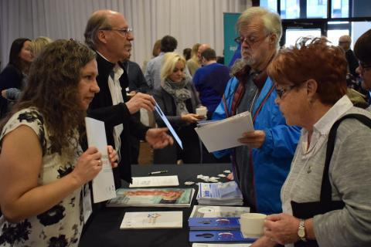

Robert Pilon, community organizer - [robert.pilon@flhlmq.com](mailto:robert.pilon@flhlmq.com)

Elisabeth Pham, Administrative Director - [elisabeth.pham@flhlmq.com](mailto:elisabeth.pham@flhlmq.com)

Patricia Viannay, coordinator - [patricia.viannay@flhlmq.com](mailto:patricia.viannay@flhlmq.com)

Anik Leroux, community organizer - [anik.leroux@flhlmq.com](mailto:anik.leroux@flhlmq.com)

**no pictures found**



Summary

* [How the FLHLMQ works](https://flhlmq.com/fr/le-fonctionnement-de-la-flhlmq)
* [FLHLMQ authorities](https://flhlmq.com/fr/les-instances-de-la-flhlmq)
* [FLHLMQ Team](https://flhlmq.com/fr/equipe-de-la-flhlmq)
* [25 years of our federation (history of the FLHLMQ)](https://flhlmq.com/fr/les-25-ans-de-notre-federation-historique-de-la-flhlmq)

# PAGE - ABOUT

( <https://flhlmq.com/fr/presentation-de-la-flhlmq>)

*h1* - Presentation of the FLHLMQ

Founded in 1993, the Fédération des locataires d'habitations à louer modique du Québec (FLHLMQ) brings together more than 300 HLM tenant associations and residents' advisory committees (CCR) spread across the entire territory of Quebec.

The mission of the FLHLMQ is:

* to promote and defend the interests of tenants and work to improve their quality of life;
* to provide support for the work carried out locally by tenants’ associations;
* to promote the involvement and support of tenants in social housing;
* to represent tenants before political and administrative bodies.

The FLHLMQ is run by a board of directors of 18 tenants representing the different regions of Quebec. They are elected for two years, during the FLHLMQ convention. Each of them is responsible for links with the associations and CCRs of their region, in addition to being the organizer of the regional activities of the FLHLMQ.

If you want to know more about the democratic functioning of the FLHLMQ, you can consult our general regulations.

Document

[GENERAL REGULATIONS OF THE FLHLMQ- 2021.pdf](https://flhlmq.com/sites/flhlmq.com/files/2022-09/R%C3%88GLEMENTS%20G%C3%89N%C3%89RAUX%20DE%20LA%20FLHLMQ-%202021.pdf)

[ <https://flhlmq.com/sites/flhlmq.com/files/2022-09/R%C3%88GLEMENTS%20G%C3%89N%C3%89RAUX%20DE%20LA%20FLHLMQ-%202021.pdf>]

The FLHLMQ employs 4 people: Robert Pilon, Élisabeth Pham, Patricia Viannay and Anik Leroux. The federation's offices are located in Montreal.

* [How the FLHLMQ works](https://flhlmq.com/fr/le-fonctionnement-de-la-flhlmq)
* [FLHLMQ authorities](https://flhlmq.com/fr/les-instances-de-la-flhlmq)
* [FLHLMQ Team](https://flhlmq.com/fr/equipe-de-la-flhlmq)
* [25 years of our federation (history of the FLHLMQ)](https://flhlmq.com/fr/les-25-ans-de-notre-federation-historique-de-la-flhlmq)

[How the FLHLMQ works ›](https://flhlmq.com/fr/le-fonctionnement-de-la-flhlmq)

## historical section

( [https://flhlmq.com/fr/les-25-ans-de-notre-federation-histoire-de-la-flhlmq](https://flhlmq.com/fr/les-25-ans-de-notre-federation-historique-de-la-flhlmq) )

*h1* - The 25 years of our federation (history of the FLHLMQ)

*h3* - To mark its 25th anniversary, the FLHLMQ has published a series of short articles on its history in the form of a weekly serial. Thanks to André Giroux for writing these articles.

In Quebec, HLM really came into being in the 1970s to house citizens who had been evicted from their homes to make way for the major revitalization projects of the time. We can recall the demolitions caused by the passage of Highway 40 through Trois-Rivières, the construction of the Radio-Canada building in Montreal and Place du Portage on Hull Island, as well as the closure of villages in the center of the Gaspé Peninsula. To avoid protests, all displaced people were invited to come and live in beautiful, brand new HLMs at very low rents. It was therefore a diversity of populations that made up the first HLMs ensuring a right to housing for all.

In the 1980s, with social policies becoming more stringent, governments in Quebec decided to restrict access to low-cost housing to only the most deprived populations. By amending the regulations on rent setting and the rules for allocating housing, working households were gradually driven out. So much so that from 1978 to 1989, the proportion of tenants declaring a work income dropped from 20% to 7%. To hammer a further nail into the concept of social housing accessible to all, Brian Mulroney's Conservative government announced in 1993 that the federal government was unilaterally withdrawing from the construction of new low-cost housing. The country's social housing shortage had just begun.

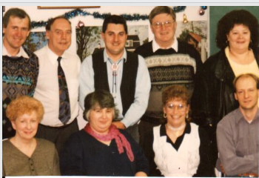

It was in this context that the Front d'action populaire en réaménagement urbain (FRAPRU) had the good idea, in 1993, to encourage eight associations of social housing tenants to create the Fédération des locataires d'habitations à louer modique du Québec (FLHLMQ). Ironically, the only FRAPRU employee who voted against this project became the coordinator of the FLHLMQ, and has been for 25 years.

From the beginning, the main objective that animated the Federation was democracy. In some offices such as those of Montreal, Quebec and Trois-Rivières, the creation of tenants' associations was supported while in other cities, they were prohibited. It was therefore necessary to have the right of association of HLM tenants recognized in order to give them a voice in dealing with the managers of the OMH.

Quickly, other issues were added to the Federation's battles so that tenants feel at home in a social housing project. As much small, daily battles, in particular on the right to own pets or simply choose the color of the paint of one's accommodation, as larger battles to prevent the increase of our rents, obtain budgets for the renovation of our buildings or prevent the privatization of social housing.

Over the coming weeks, we will present to you the events and issues that have marked the history of the Federation over the past 25 years, in order to take stock of the achievements made and what awaits us over the coming years.

*h3 -* Photo: Members of the FLHLMQ board of directors in 1995.

*h3 -* The battles for democracy

As early as 1993, the first challenge that the Fédération des locataires d'habitations à louer modique du Québec (FLHLMQ) was faced with was the need to obtain recognition of the right to have a tenants' association. The theme of the first congress, held in 1995, was "A greater place for tenants". This theme particularly reflected the spirit of the times.

"We felt that some HLM administrators, fortunately not all but there were several, acted as if the tenants were less than nothing, remembers Robert Pilon, coordinator of the Federation since the beginning. Their management was at best paternalistic, at worst very authoritarian. This reflected the fact that HLM tenants considered themselves failures: failure in employment, in life as a couple, failure at school, in leisure and in consumption."

Hence the theme of the first congress to assert that social housing tenants are citizens in their own right and capable of living in social housing.

The battle for democracy involved the right to be informed, consulted and to form associations. The reality was that in Longueuil, Chicoutimi and Bromont, leaders refused to recognize tenant associations. At the time, in practice, the recognition of associations was at the discretion of local leaders, who decided whether they would accept them with the funding and provision of premises that this entailed, tolerate them or reject them.

Some offices, such as the one in Montreal, accepted recreation committees, per building, but did not want them to come together to negotiate. This was the most progressive practice at the time. Many offices boasted about not having tenants' associations and clearly stated that they did not want them, on the pretext that it would create disruption.

In Bromont, some formidable female tenants, including Isabelle Marrisal who would later become president of the FLHLMQ, had received letters from lawyers stating that they had to leave the following July 1 because they had tried to create an association.

In Longueuil, courageous women fought for seven years to establish a tenants' association. The [OMH](http://flhlmq.com/categorie/hovertips/omh) refused to recognize it under the leadership of Mayor Claude Gladu.

The Federation obtained its first victory in April 1998, after filing a petition of 30,000 names to obtain recognition of the right of association in HLM and holding the largest demonstration of HLM tenants, more than 700, in front of the National Assembly and in front of the congress of the Regroupement des offices d'habitation du Québec. In June 1998, the [SHQ](http://flhlmq.com/categorie/hovertips/shq) issued a directive asking [HMOs](http://flhlmq.com/categorie/hovertips/omh) to recognize, finance and consult tenant associations. At the time, the president of the Federation, Claude Gelderblom, from Rivière-du-Loup, enthusiastically declared that this gain represented a "true quiet revolution for HLM". And this, for two reasons:

* Giving tenants who wish to do so the opportunity to become actively involved in the management of their building will improve the quality of services and help to give a more positive image of public housing, both in the eyes of politicians and the public;
* This commitment by tenants gives them the opportunity to revalue themselves in their own eyes, thus reclaiming their dignity.

Despite this initial gain, tenants experienced the hard way that offices ignored the administrative directive because it did not have the force of law. The FLHLMQ therefore went back on the offensive to have the tenants' right to association included in the Société d'habitation du Québec Act.   
In April 2002, the [SHQ Act](http://flhlmq.com/categorie/hovertips/shq) was amended to include two new rights for HLM tenants: the obligation for offices to recognize all associations that comply with the SHQ directives [and](http://flhlmq.com/categorie/hovertips/shq) the obligation for all offices to create a residents' advisory committee ( [CCR](http://flhlmq.com/categorie/hovertips/ccr) ). According to the president of the Federation at the time, Jean-Marie Doyon of Rock-Forest, "the establishment of advisory committees will give us the chance to change the face of HLM."

These achievements made it possible to create dozens of resident advisory committees ( [RACs](http://flhlmq.com/categorie/hovertips/ccr) ) throughout Quebec over the next fifteen years. Several [RACs](http://flhlmq.com/categorie/hovertips/ccr) are very proud of what they have achieved since then. However, more than half of the offices have never set up a [RAC](http://flhlmq.com/categorie/hovertips/ccr) .

According to Élisabeth Pham, who has worked at the FLHLMQ since 2003, "this shows us that it was much easier to obtain a legislative change than to obtain a real change in attitude on the ground. It's a daily battle. Even today, many active people are afraid of suffering reprisals: fear of losing their housing, of displeasing the administrators."

These fears are based on concrete facts: threats of being moved to a smaller place or to a neighborhood that the tenant does not like.

The power relationship still exists. In 2011, in a survey by the Société d'habitation du Québec ( [SHQ](http://flhlmq.com/categorie/hovertips/shq) ), 49% of office directors opposed tenant associations. However, HLM is a world where 70% of tenants are single women, while the directors are still mostly men.

It is therefore always an enormous challenge for people excluded from everything to learn to occupy the democratic spaces which are nevertheless the fruit of their struggles.

This is why the Federation remains very present on the ground to support tenants who want to organize themselves.

*h3* - In the photo: Claude Gelderblom, president of the FLHLMQ, in 1998, in front of the National Assembly.

*h3* - [The battle for the return of workers to social housing](http://flhlmq.com/content/la-bataille-pour-le-retour-des-travailleuses-et-travailleurs-dans-les-hlm-historique-38)

From the creation of the Federation in 1993, it was obvious to all residents that HLM had become a very difficult living environment. This was because in the early 1980s, the Quebec government had changed the rules in two ways:

* By abolishing the Rogers scale, which established the rent according to a scale of 16% to 25% of the main income in the household, to replace it with a rent established at 25% of the two main incomes, without a ceiling.
* By restricting the allocation rules through a weighting system aimed at prioritizing only the poorest, thereby excluding households working even at the minimum wage.

The result was that large housing complexes of 200 to 400 homes had only three or four working households. This created poverty ghettos where it was becoming more difficult to raise a family than in the 1970s and 1980s. A researcher, Paul Morin, coined the term social trap to indicate that it was also becoming more difficult to escape.

In 1993, the Minister of Municipal Affairs at the time, Claude Ryan, wanted to go further by considering all family incomes, including those of children. The outcry was such that it was the mobilization of tenants to maintain the rent of social housing that allowed the Front d'action populaire en réaménagement urbain (FRAPRU) to create the Federation. This battle resulted in a partial gain, namely the setting of a flat rate for young people aged 18 to 24 living with their parents. It is only at the age of 25 that the percentage rises to 25% of their income.

*h3* - Two significant gains

In the early 2000s, under the presidency of Isabelle Marissal of Bromont, the Federation organized several demonstrations and press conferences in several major cities in Quebec to demonstrate that, due to rent policies, it was not advantageous to work for a low wage while remaining in low-income housing. The Federation obtained an amendment to the regulations from the Minister responsible for Housing, Louise Harel, to obtain a protected rent. This means that the rent of people who start working will gradually increase, thus allowing these people to remain in low-income housing longer. Tenants of housing cooperatives and housing owned by non-profit organizations ( [NPOs](http://flhlmq.com/glossary/term/93) ) also benefited from this measure. The Federation's objective was to develop a certain diversity in low-income housing.

It was also with the aim of increasing social diversity that in 2011, after 19 years of tenacious representations, the Federation obtained an amendment to the Regulation on the allocation of HLM in order to take into account the seniority of the request. It was no longer only the poorest of the poorest who had access to HLM. It included people with diverse experiences, thus providing a living environment where it is more pleasant to live.

In 2011, the [SHQ](http://flhlmq.com/categorie/hovertips/shq) promised a study on the impact of this measure on social diversity for 2016. It is still expected in 2018.

*h3* - Two setbacks avoided

When Lucien Bouchard became Premier of Quebec, in the aftermath of the 1995 referendum, he launched the fight for a zero deficit. With this obsession in mind, his government came within a hair's breadth of transferring responsibility for low-cost housing to municipalities, without the corresponding budgets. This would have been a royal road to their privatization. In Ontario, for example, under the leadership of Mike Harris' common sense revolution, the transfer to municipalities led to the sale of low-cost housing to the private market. In Quebec, it was the public exit of the Federation, in alliance with FRAPRU, that forced the government to back down.

Subsequently, Rémi Trudel and the PQ announced the project to reduce the rent to 30% of income in low-income housing over five years, at a rate of 1% per year. Through their mobilization, including a petition submitted to all MPs, low-income housing tenants obtained the rejection of this measure, while almost everywhere else in Canada, this proportion has been at 30% for nearly twenty years.

*h3* - The battles for renovations!

When Jean Charest came to power in 2003, the total budget allocated to HLM was $50 million per year to renovate and maintain 63,000 HLMs. The first decision of the new Minister responsible for Housing, Jean-Marc Fournier, was to reduce this budget to $30 million.

There was not a single city, not a single social housing project, where tenants managed to get their old carpets changed or a new kitchen hood, much less the renovation of their 30-year-old kitchen or bathroom. Zero renovations, except for emergencies or the restoration required for relocation. Moreover, the [SHQ](http://flhlmq.com/categorie/hovertips/shq) estimated the accumulated maintenance deficit for the renovation of all social housing in Quebec at nearly $4 billion.

Under the presidency of Nicole Sirois, from Estrie, the Federation initiated a petition that collected nearly 54,000 signatures. The document demands that the Liberals increase the amounts allocated to the renovation of low-cost housing to $100 million per year. One hundred and ten members of parliament stood up in turn in the National Assembly to read the contents of the petition submitted by low-cost housing tenant associations in their ridings. Many members of parliament from all parties were sympathetic to our cause, but Minister Fournier remained intractable.

The year 2007-2008 saw the most serious global economic crisis since the Great Depression of the 1930s. Canada fared somewhat better than other countries thanks to an infrastructure program that the federal government created at the same time.

To everyone's surprise, in December 2007, Jean-Marc Fournier's replacement, Nathalie Normandeau, invited FLHLMQ representatives to a press conference in a low-cost housing project next to our offices in the Little Burgundy district of Montreal. She announced a fifteen-year low-cost housing renovation program: this federal-provincial program, worth $260 million per year, is indexed. So much so that in 2017, it totaled $360 million. In ten years, three billion dollars were invested in low-cost housing renovations. According to the SHQ, we are 79% complete in the renovation work on low-cost housing. FLHLMQ coordinator Robert Pilon recalls that in the photo taken with the minister, he couldn't smile because it seemed too good to be true

According to him, it is "a historic victory that guarantees the survival of HLMs because of the money invested. These are proportionally higher investments than in schools, for example. However, there are still a multitude of local battles to be fought to ensure that this money is spent to meet the real needs of tenants."

h3- Battles in the National Assembly of Quebec

In 25 years, the FLHLMQ has repeatedly defended the cause of HLMs before the members of parliament in Quebec City. Here is a brief overview of the sometimes courageous or visionary positions that we have taken following debates at the congress.

March 4, 1995 -

h3-

Let's take the risk of independence if the project is worth it! FLHLMQ presentation to the Commission des aînées et aînés sur l'avenir du Québec.

December 1, 2000 -

h3- Mergers can promote the management and development of social housing for disadvantaged populations in large cities. FLHLMQ presentation to the Territorial Planning Commission on Bill No. 70.

October 24, 2002 –

h3- For modern and transparent management of HLMs to encourage tenant participation. FLHLMQ presentation to the Commission on Land Use Planning on Bill No. 49.

February 6, 2004 –

h3- Four major projects to develop HLMs in Quebec. Presentation as part of the pre-budget consultations of the Ministry of Finance of Quebec.

February 14, 2005 –

h3- The health of the population comes well before the health of the pharmaceutical industry. FLHLMQ presentation to the Social Affairs Commission.

March 2013 –

h3- Work that changes the face of low-cost housing. FLHLMQ presentation to the Quebec Ministry of Finance.

January 20, 2016 –

h3- To put an end to the scattering of resources and offer better services to low-cost housing tenants in Quebec. FLHLMQ presentation to the Minister of Municipal Affairs.

January 2016 -

h3- A proposal to reduce poverty in low-cost housing - Transferring maintenance to tenants. Presentation as part of the Solidarity and Social Inclusion public consultation.

2016-2017 – More than 300 tenants participated in the consultation tour organized by MNA Norbert Morin and the SHQ on a new approach to housing intervention in about twenty cities in Quebec.

Each time, it was a rich but demanding experience for the tenants who succeeded one another on the FLHLMQ board of directors to go and speak in the National Assembly with all its decorum.

-6-

h3- The battle of the referendums

From the first months of its existence, in 1993, the issue of the presence of animals in low-rent housing concerned the Fédération des tenants d'habitations à rent modique du Québec (FLHLMQ). At the time, two Longueuil residents, Fleurette Trottier and Denise Blanchard,

were fighting in court to keep one her dog, the other her two cats. After losing before the Régie du logement, Ms. Trottier appealed her case and won before the Court of Québec on technical grounds.

In solidarity with their fight, the Federation asked the Société d'habitation du Québec (SHQ) to force OMHs to allow pets in HLMs. Even though the Association des OMH du Québec (now called the Regroupement des offices d'habitations du Québec) recommended at the time that its members show tolerance, only a few dozen cities, including Montreal and Quebec City, allowed pets.

It would take five years, and many pathetic cases of evicted tenants, including that of Ezzy the cat in Superior Court, for the FLHLMQ to persuade the Minister of Municipal Affairs, Louise Harel, in 1998 to give tenants the decision-making power to decide whether or not to allow pets. “The idea of ​​giving tenants the power to hold a referendum on animals appealed to the minister, who was very familiar with the outcome of referendums, having experienced two unfortunate ones very closely,” said Robert Pilon, FLHLMQ coordinator. The adoption in 2002 of an amendment to the Act respecting the Société d'habitation du Québec, which required offices to have a Residents' Advisory Committee (RAC), led the SHQ to amend its Social Housing Management Guide to mandate the RACs to “provide , in collaboration with the office, a secret ballot mechanism to allow tenants to vote on the presence of animals in HLM.” » In addition, "if a majority of tenants are in favor of the presence of animals in HLM, the office will not be able to prohibit it in a general manner and will have to issue guidelines to this effect and integrate them into the building regulations (…)”

“The question of animals is the only issue on which tenants have obtained real decision-making power, but unfortunately it is still little known or sometimes hidden from residents,” emphasizes Robert Pilon. Since 2002, some fifty tenant associations have organized a referendum on animals. The FLHLMQ recommends the following wording for the referendum, to which it suggests voting YES:

Would you agree that

1. the OMH authorize the presence of animals by requiring that tenants comply with the following conditions: A CAT, ON THE CONDITION THAT IT IS OPERATED, DECLAWED AND KEPT INSIDE THE ACCOMMODATION; or A DOG, ON THE CONDITION THAT IT DOES NOT BARK, IS ALWAYS ON A LEASH OUTSIDE AND THAT THE EXCREMENT IS PICKED UP.

2. That the office takes firm action against tenants who do not comply with these new rules. Check your choice:

YES___ NO___

To date, more than half of the 443 OMHs, including the one in Longueuil, allow cats or dogs. The situation has changed a lot in Longueuil since 1993 regarding the right to own an animal. In many other cities too!

Photo: Demonstration in front of Longueuil City Hall in 1994 organized by the FLHLMQ.

Monik Desjardins joined the Fédération des tenants d'habitations à rent modique du Québec (FLHLMQ) in 1994, a year after the Federation was founded. She then became a member of the board of directors, representing the HLM des Hirondelles, which she had joined in 1989. This was the beginning of a long experience that is still ongoing in 2018.

One of Monik's most memorable experiences was her meeting, in April 1998, with Jean Campeau, then the PQ MNA for Crémazie. Before his election, he had co-chaired the Bélanger-Campeau Commission, which focused on the political and constitutional future of Quebec. He was also Minister of Finance and Revenue (1994–1995) in the Jacques Parizeau government.

During her meeting with Jean Campeau, Monik was acting as spokesperson for the seven tenant associations in the Ahuntsic district, representing 600 households. She gave the MNA a petition with 500 names. The petition asked the government to remain the owner of HLM rather than transferring them to municipalities, not to increase their rent to 30% of their income as was increasingly being done in English Canada, to encourage low-income working households and to adopt a regulation promoting holding participation in the management of their buildings. Over the years, the signatories would win their case, thanks to the petition that obtained 50,000 names in Quebec.

“Mr. Campeau is the only MNA who came to join us at the 700-person demonstration that the Federation organized in front of the National Assembly of Quebec,” emphasizes Monik Desjardins.

The following year, at the third congress of the Federation, she became secretary of the organization and vice-president of the OMH of Montreal. “I thought that

The following year, at the third congress of the Federation, she became secretary of the organization and vice-president of the OMH of Montreal. "I who thought I was just a bs, I gained confidence in myself “Since I 've been in HLM,” she declared a few years later to Josée Boileau, journalist for the daily Le Devoir.

One of the events that gave Monik confidence was his intervention before the parliamentary committee on the possibility of merging the housing offices, which the Federation proposed in 2001.

“The mayor of Sainte-Foy, Andrée Boucher, came before us,” remembers Monik. The coordinator of the Federation, Robert Pilon, suggested that I take inspiration from her. When it was my turn to speak, Louise Harel, then PQ minister, congratulated me on being the first tenant sitting on the executive committee of an OMH. Ms. Fatima Houda-Pepin, a liberal MP, also congratulated me even though I had disagreements with her. I still remember it, 17 years later. »

A disagreement with the OMH of Montreal, which had refused to follow up on a decision taken at the tenants' assembly, led Monik to resign from his elective functions.

She will return to the Federation ten years later, in 2012, for at least two days a week, as a volunteer. She is the one who answers the phone and gives you valuable advice which is the fruit of her vast experience.

It is thanks to Monik and the two thousand volunteers involved in HLM tenant associations in Quebec that the FLHLMQ has existed for 25 years.

# PAGE - CONTACT US

(https://flhlmq.com/fr/nous-joindre)

h1- Contact us

To contact the Federation of Low-Rent Housing Tenants of Quebec (FLHLMQ).

h3- by telephone:

(514) 521-1485

1-(800)566-9662

h3- by email:

info@flhlmq.com

Robert Pilon

Community Organizer

- Elisabeth Pham

Administrative Director

h3-

by fax:

(514) 521-6444

h3- WEBSITE:

flhlmq.com

Patricia Viannay

Coordinator

Anik Leroux [https://flhlmq.com/fr/anik.leroux@flhlmq.com]

Community organizer

h3- by post:

2520, av.Lionel-Groulx, local 202 Montréal, (Quebec)

H3J 1J8

h3- on Facebook:

# 

# PAGE - FAQ

H3- How can I register?

To register, click the "Register" button at the top right of the home page and follow the instructions.

H3- Is my personal information secure?

Yes, we take the security of your data very seriously. See our privacy policy for more information.

H3-Are the services chargeable?

Yes, some services require payment. You will find information on prices in the “Prices” section of our site.

H3- Are your services accessible to everyone?

Yes, we are committed to making our services accessible to a general public. If you have any specific needs, please let us know.

# PAGE-ERROR 404

(https://flhlmq.com/fr/ghfd)

h1- Page not found

The requested page could not be found.